Stalin on the History and Study of Society
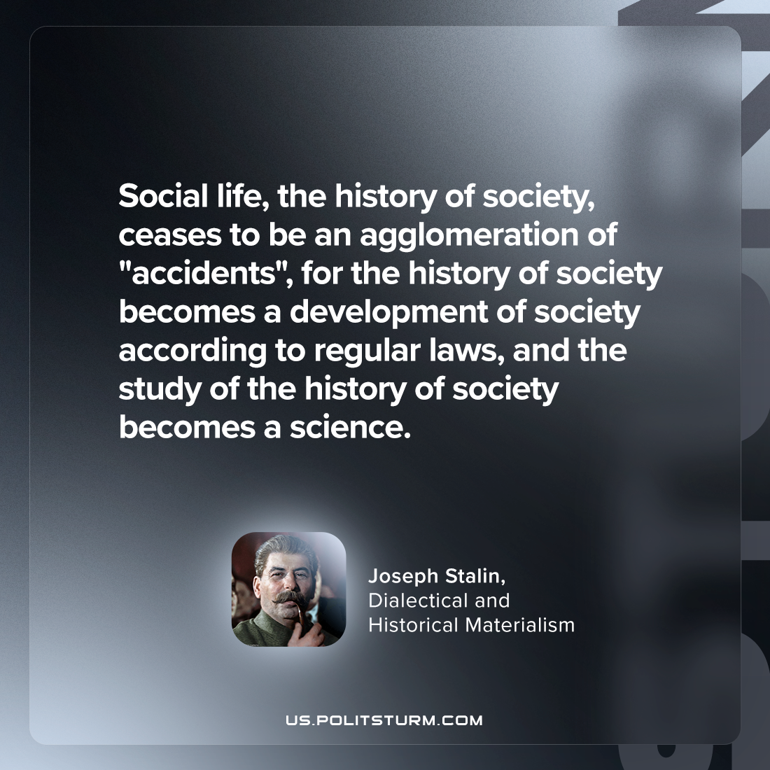

Original article
2024-01-06

"Social life, the history of society, ceases to be an agglomeration of "accidents", for the history of society becomes a development of society according to regular laws, and the study of the history of society becomes a science."
Joseph Stalin, Dialectical and Historical Materialism

Original article

