Stalin on the Fragility of Peace
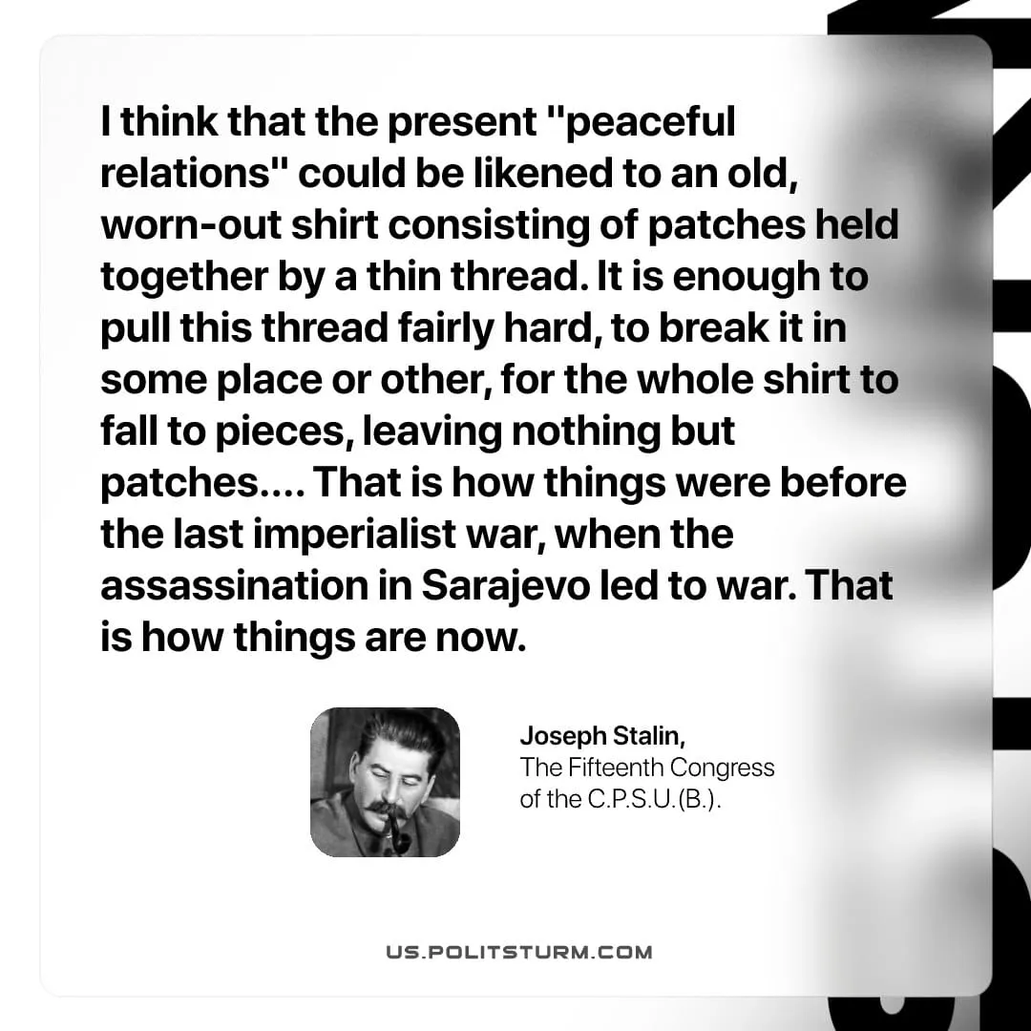

Original article
2026-05-14
1 min read

I think that the present "peaceful relations" could be likened to an old, worn-out shirt consisting of patches held together by a thin thread. It is enough to pull this thread fairly hard, to break it in some place or other, for the whole shirt to fall to pieces, leaving nothing but patches. ... That is how things were before the last imperialist war, when the assassination in Sarajevo led to war. That is how things are now.
Joseph Stalin, The Fifteenth Congress of the C.P.S.U.(B.)

Original article

