Stalin on the Foundations of Socialist Society
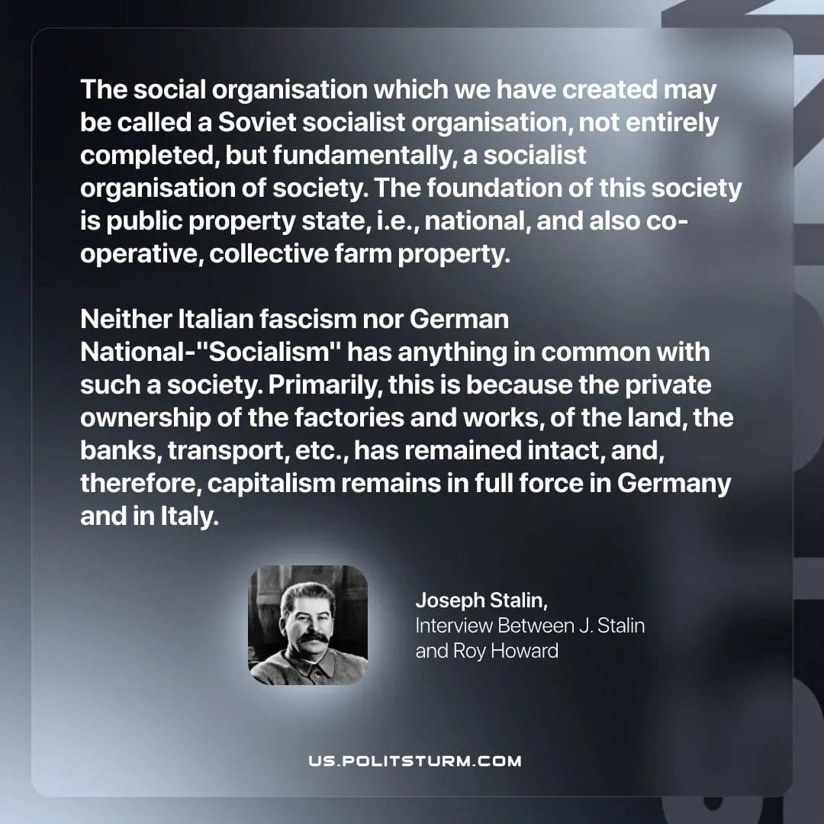

Original article
2026-04-28
1 min read

The social organisation which we have created may be called a Soviet socialist organisation, not entirely completed, but fundamentally, a socialist organisation of society. The foundation of this society is public property state, i.e., national, and also co-operative, collective farm property.
Neither Italian fascism nor German National-"Socialism" has anything in common with such a society. Primarily, this is because the private ownership of the factories and works, of the land, the banks, transport, etc., has remained intact, and, therefore, capitalism remains in full force in Germany and in Italy.
Joseph Stalin, Interview Between J. Stalin and Roy Howard

Original article

