Stalin on the Economic Crisis
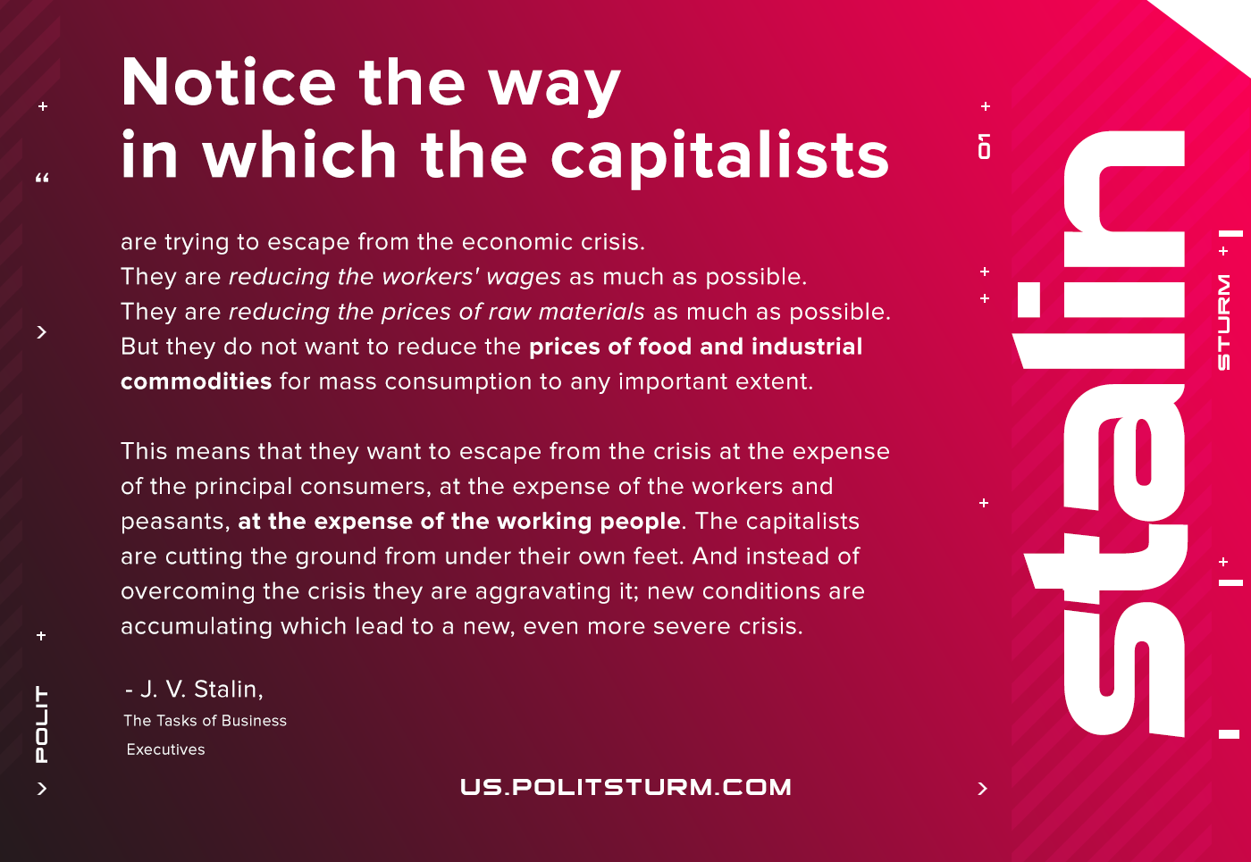

Original article
2020-11-15
1 min read

Notice the way in which the capitalists are trying to escape from the economic crisis. They are reducing the workers’ wages as much as possible. They are reducing the prices of raw materials as much as possible. But they do not want to reduce the prices of food and industrial commodities for mass consumption to any important extent.
This means that they want to escape from the crisis at the expense of the principal consumers, at the expense of the workers and peasants, at the expense of the working people. The capitalists are cutting the ground from under their own feet. And instead of overcoming the crisis they are aggravating it; new conditions are accumulating which lead to a new, even more severe crisis.
J. V. Stalin, The Tasks of Business Executives

Original article

