Stalin On The Division of Mankind
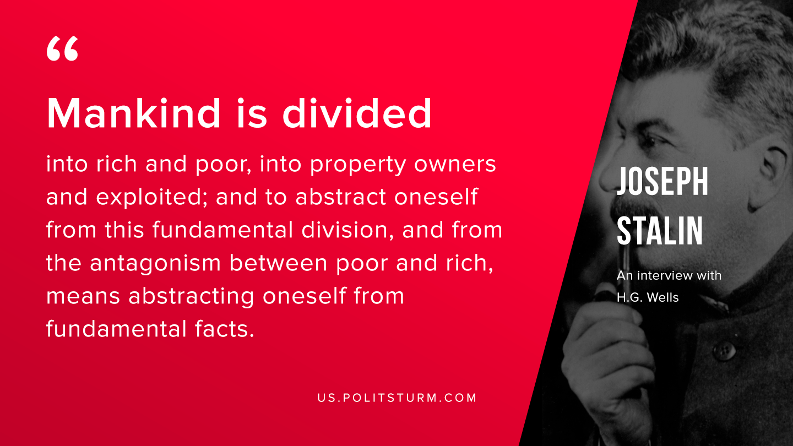

Original article
2019-09-14

Mankind is divided into rich and poor, into property owners and exploited; and to abstract oneself from this fundamental division, and from the antagonism between poor and rich, means abstracting oneself from fundamental facts.

Joseph Stalin “An Interview With H.G.Wells”

Original article

