Stalin on the Development of Capitalism
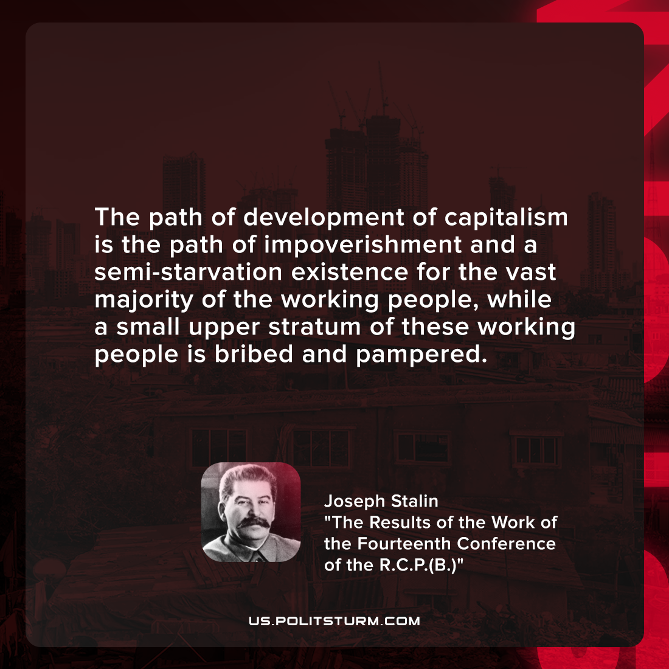

Original article
2022-01-25

The path of development of capitalism is the path of impoverishment and a semi-starvation existence for the vast majority of the working people, while a small upper stratum of these working people is bribed and pampered.

Joseph Stalin, “The Results of the Work of the Fourteenth Conference of the R.C.P.(B.)”

Original article

