Stalin on the Conditions for Real Liberation
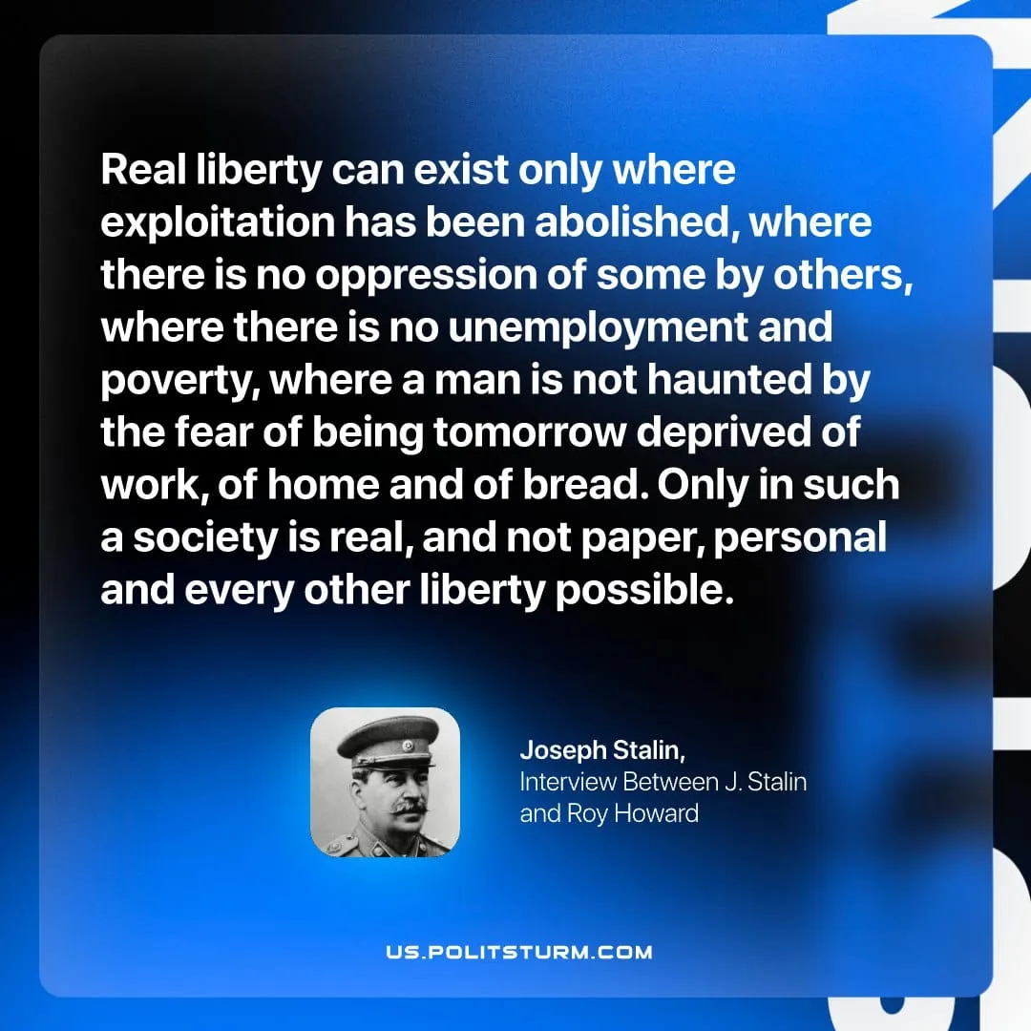

Original article
2026-04-25

"Real liberty can exist only where exploitation has been abolished, where there is no oppression of some by others, where there is no unemployment and poverty, where a man is not haunted by the fear of being tomorrow deprived of work, of home and of bread. Only in such a society is real, and not paper, personal and every other liberty possible."
Joseph Stalin, Interview Between J. Stalin and Roy Howard

Original article

