Stalin on the Class-Conscious Proletariat
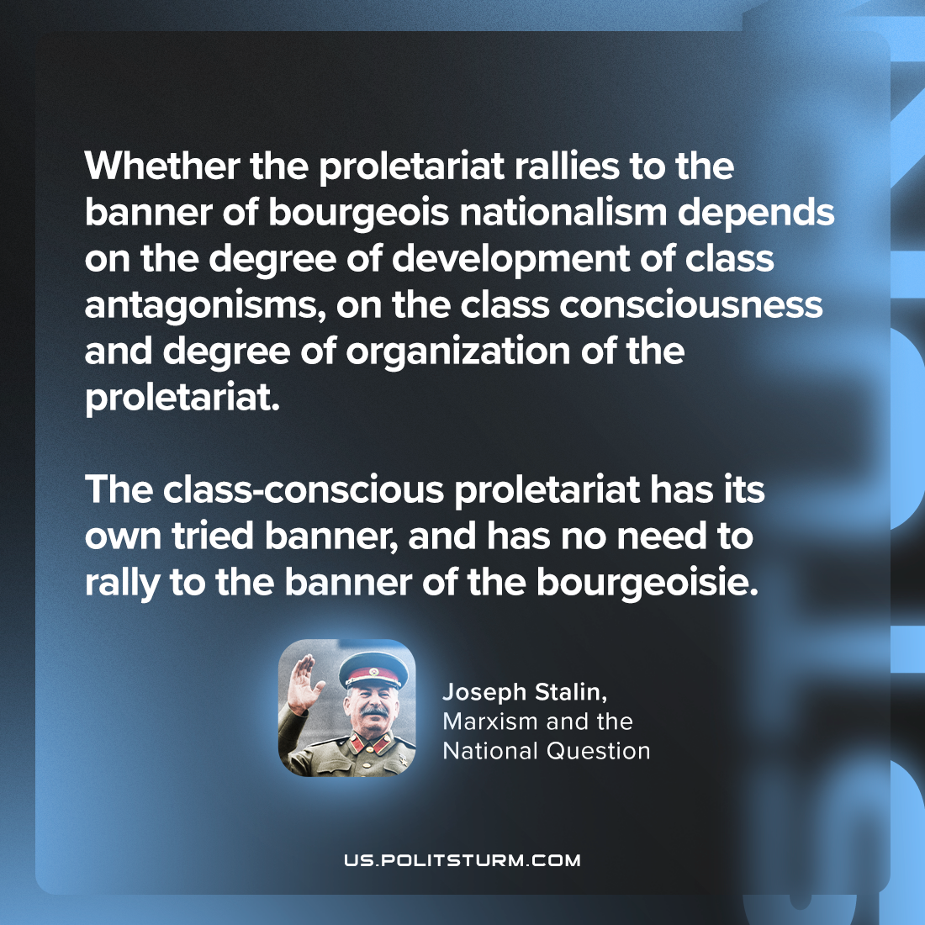

Original article
2023-11-02

"Whether the proletariat rallies to the banner of bourgeois nationalism depends on the degree of development of class antagonisms, on the class consciousness and degree of organization of the proletariat. The class-conscious proletariat has its own tried banner, and has no need to rally to the banner of the bourgeoisie."
Joseph Stalin, Marxism and the National Question

Original article

