Stalin on the Bourgeoisie
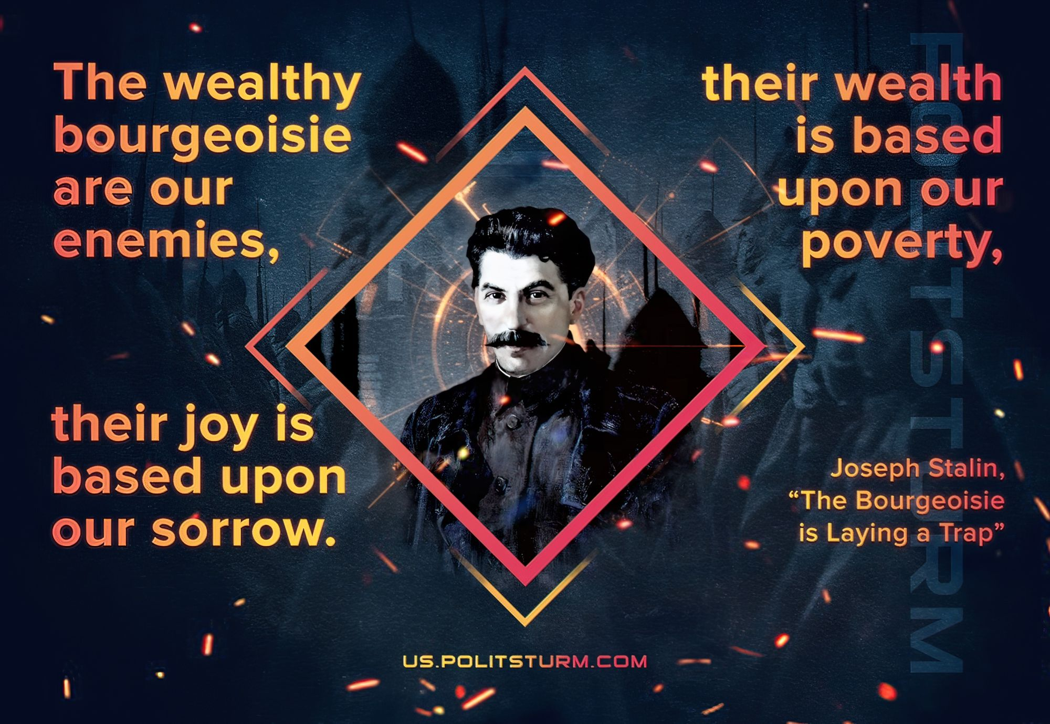

Original article
2021-07-11

The wealthy bourgeoisie are our uncompromising enemies, their wealth is based upon our poverty, their joy is based upon our sorrow.
J. V. Stalin, The Bourgeoisie is Laying a Trap

Original article

