Stalin on the Bourgeois-Democratic and the Proletarian Revolution
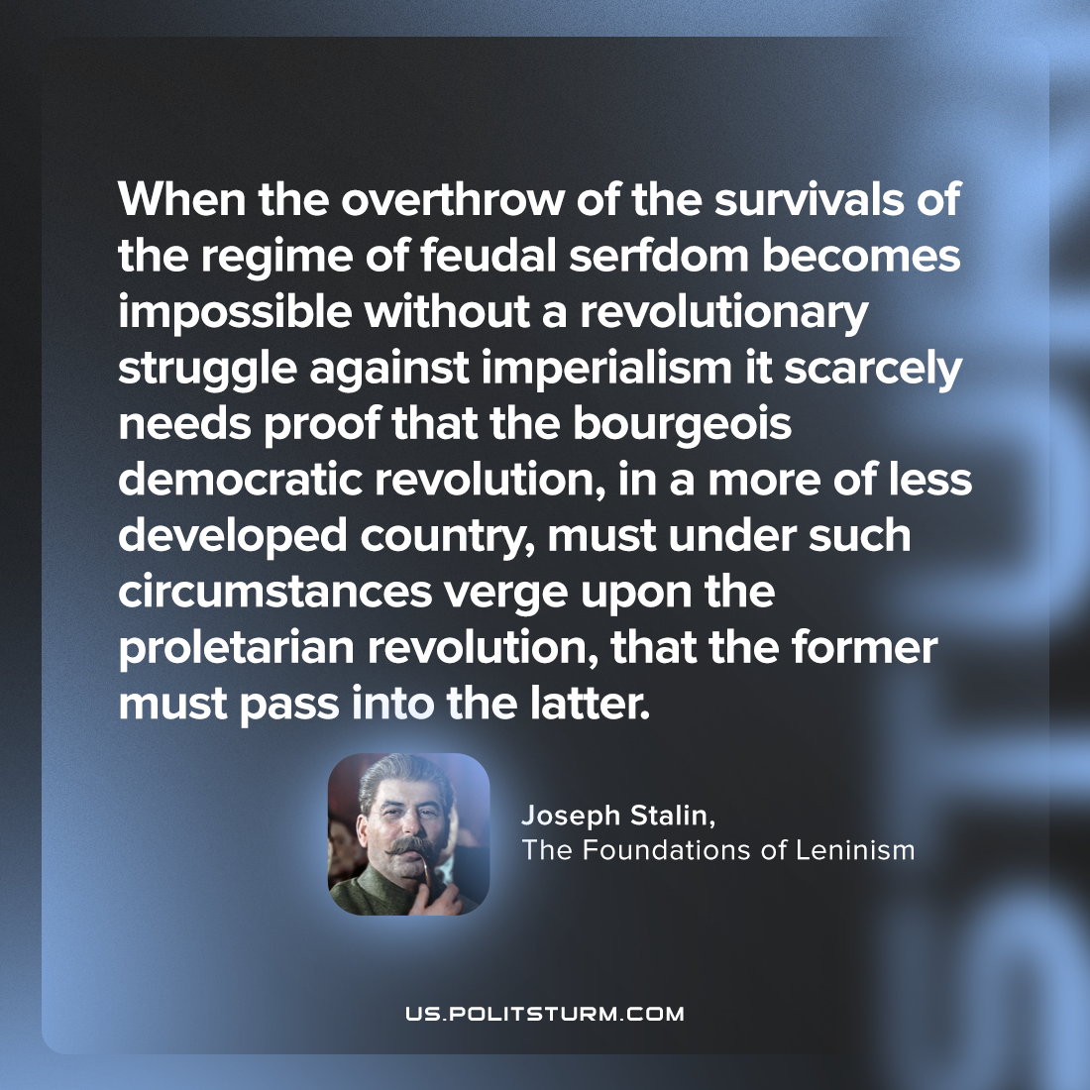

Original article
2023-06-24

"When the overthrow of the survivals of the regime of feudal serfdom becomes impossible without a revolutionary struggle against imperialism it scarcely needs proof that the bourgeois-democratic revolution, in a more of less developed country, must under such circumstances verge upon the proletarian revolution, that the former must pass into the latter."
Joseph Stalin, The Foundations of Leninism

Original article

