Stalin on the Bourgeois Constitutions
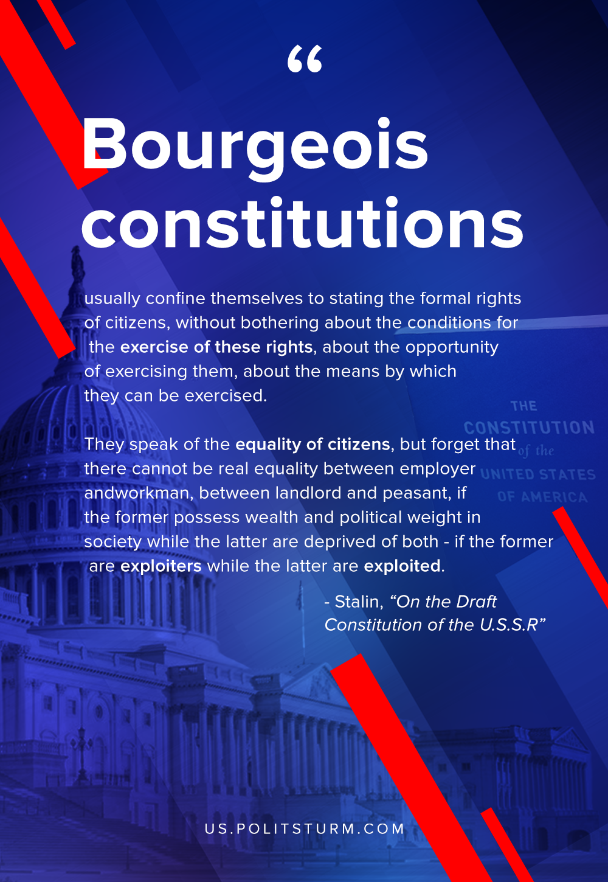

Original article
2020-03-06
1 min read

Bourgeois constitutions usually confine themselves to stating the formal rights of citizens, without bothering about the conditions for the exercise of these rights, about the opportunity of exercising them, about the means by which they can be exercised. They speak of the equality of citizens, but forget that there cannot be real equality between employer and workman, between landlord and peasant, if the former possess wealth and political weight in society while the latter are deprived of both – if the former are exploiters while the latter are exploited.
Stalin, “On the Draft Constitution of the U.S.S.R”

Original article

