Stalin on the Blackest Reaction
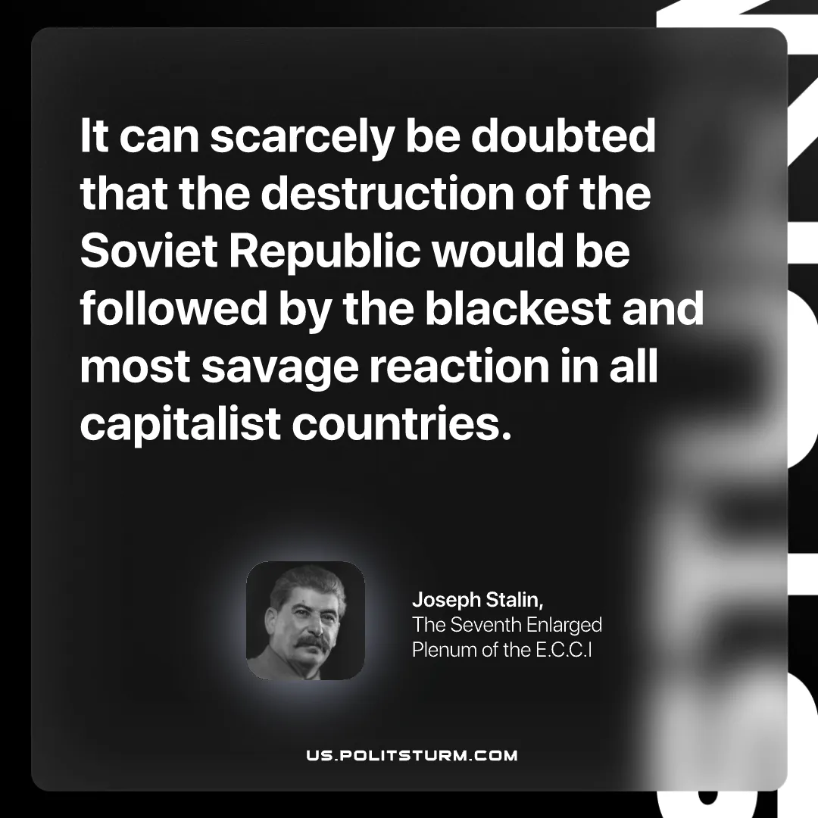

Original article
2026-09-13

It can scarcely be doubted that the destruction of the Soviet Republic would be followed by the blackest and most savage reaction in all capitalist countries.
Joseph Stalin, The Seventh Enlarged Plenum of the E.C.C.I

Original article

