Stalin on the Basis for the Growth of Opportunism
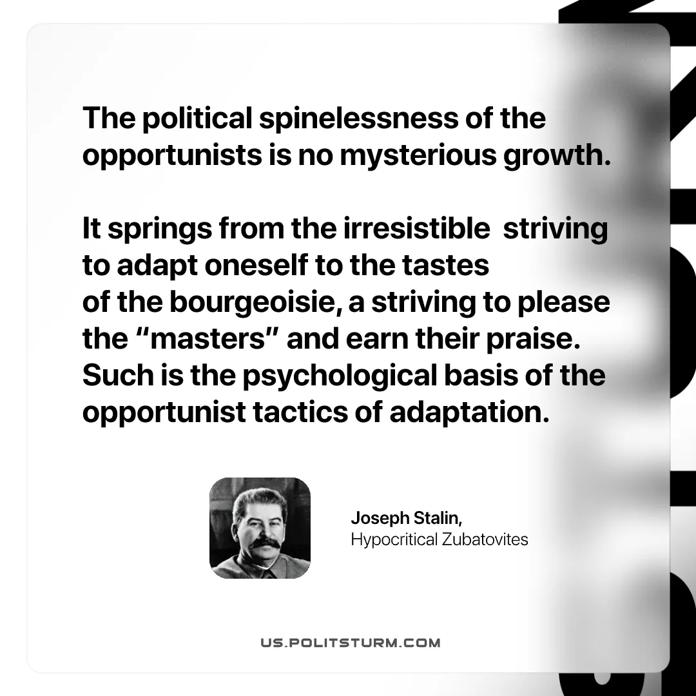

Original article
2026-01-03

"The political spinelessness of the opportunists is no mysterious growth. It springs from the irresistible striving to adapt oneself to the tastes of the bourgeoisie, a striving to please the “masters” and earn their praise. Such is the psychological basis of the opportunist tactics of adaptation."
Joseph Stalin, “Hypocritical Zubatovites”

Original article

