Stalin on the Basic Economic Law of Capitalism
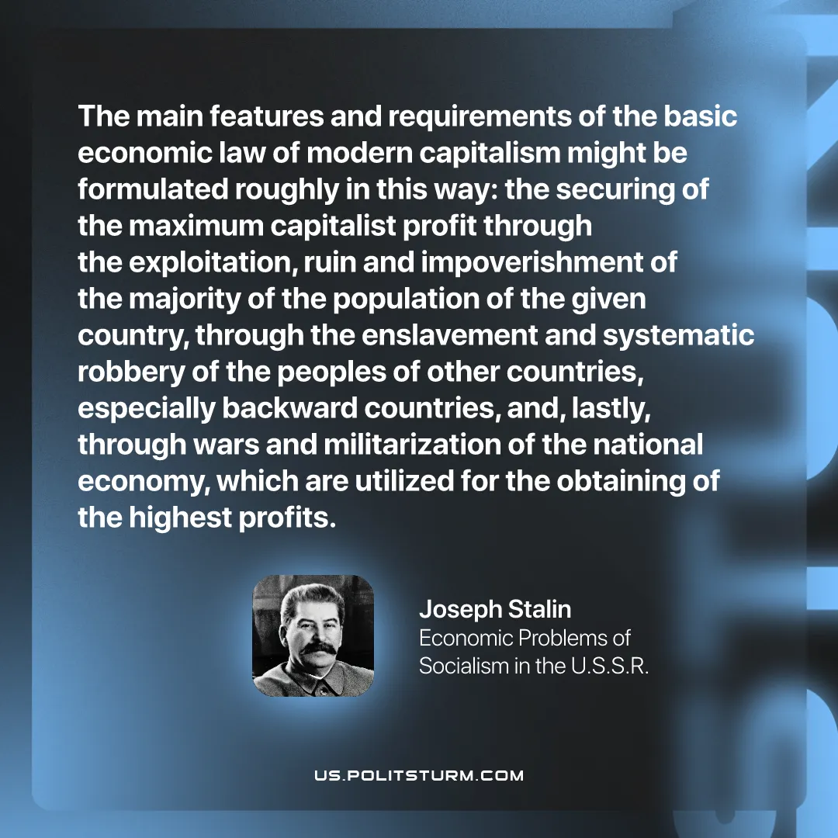

Original article
2026-01-17
1 min read

The main features and requirements of the basic economic law of modern capitalism might be formulated roughly in this way: the securing of the maximum capitalist profit through the exploitation, ruin and impoverishment of the majority of the population of the given country, through the enslavement and systematic robbery of the peoples of other countries, sspecially backward countries, and, lastly, through wars and militarization of the national economy, which are utilized for the obtaining of the highest profits.
Joseph Stalin, “Economic Problems of Socialism in the U.S.S.R.”

Original article

