Stalin on State and Capitalism
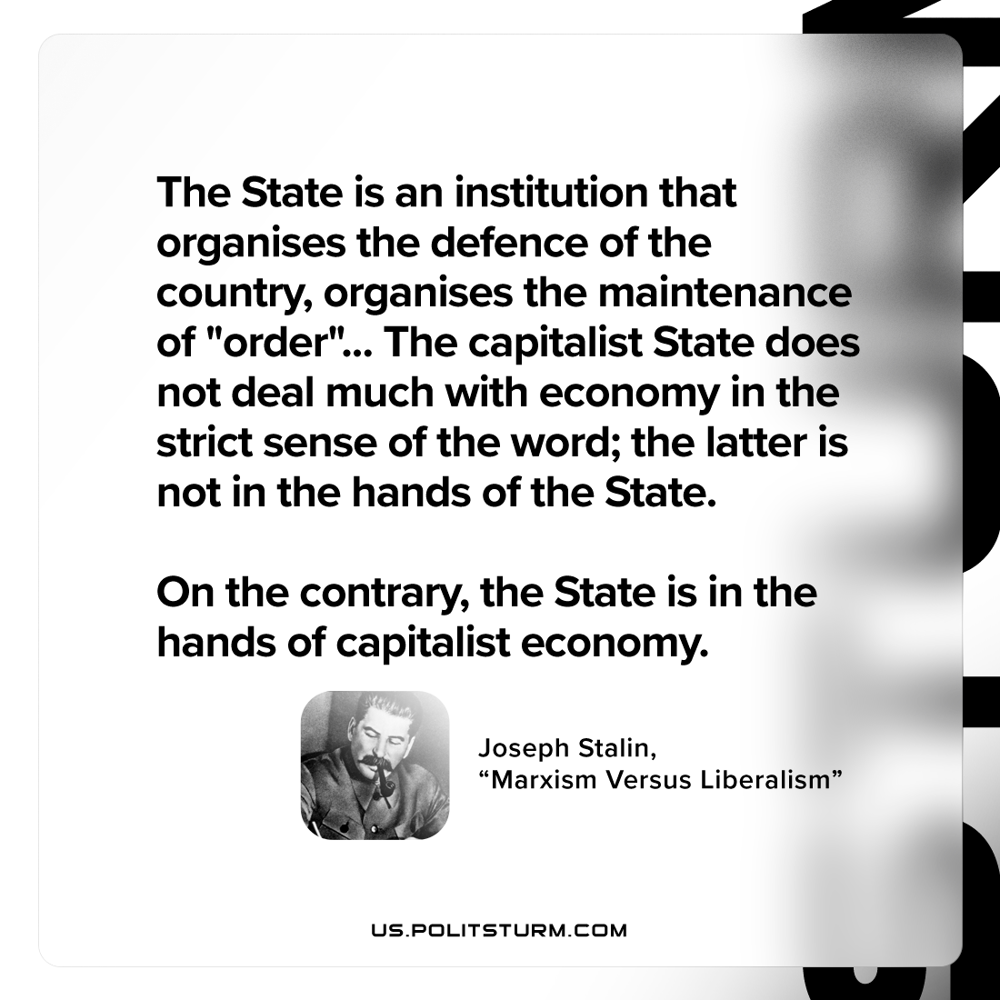

Original article
2022-12-15

"The State is an institution that organises the defence of the country, organises the maintenance of "order"... The capitalist State does not deal much with economy in the strict sense of the word; the latter is not in the hands of the State. On the contrary, the State is in the hands of capitalist economy."
Joseph Stalin, "Marxism Versus Liberalism"

Original article

