Stalin on Social Ideas and Progress of Society
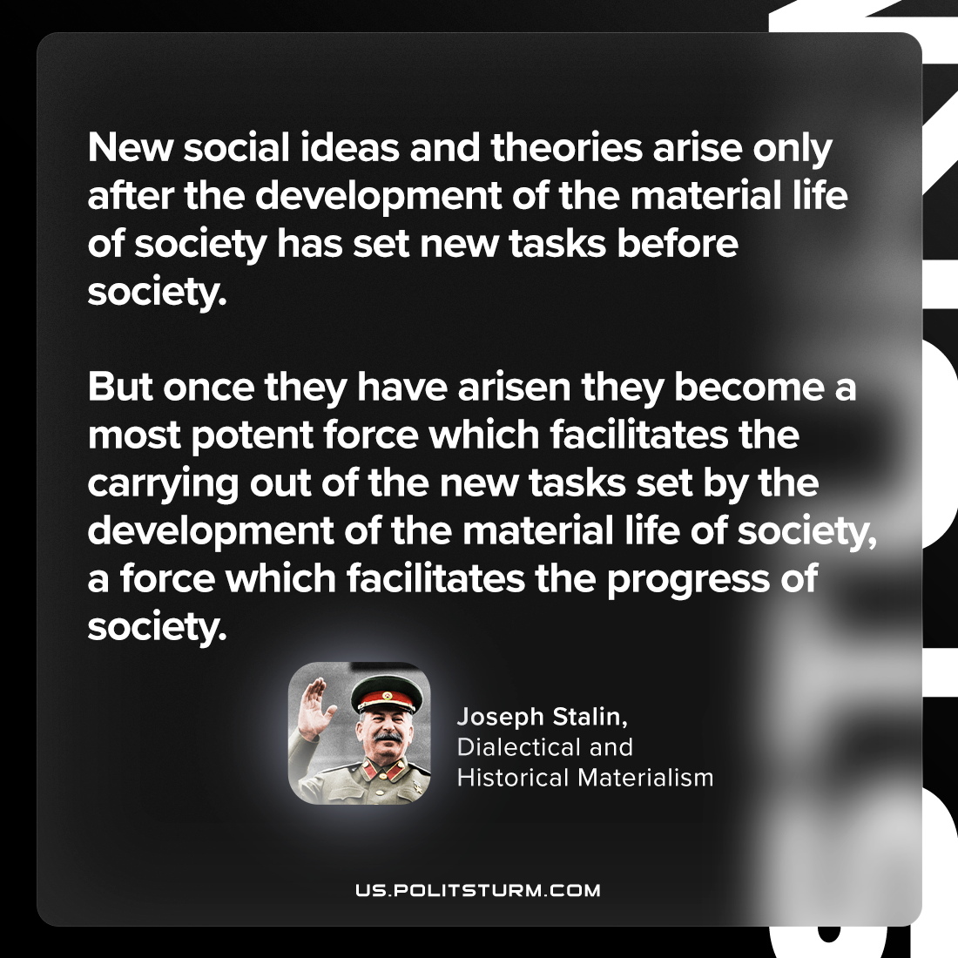

Original article
2023-08-22

"New social ideas and theories arise only after the development of the material life of society has set new tasks before society. But once they have arisen they become a most potent force which facilitates the carrying out of the new tasks set by the development of the material life of society, a force which facilitates the progress of society."
Joseph Stalin, Dialectical and Historical Materialism

Original article

