Stalin on Second World War
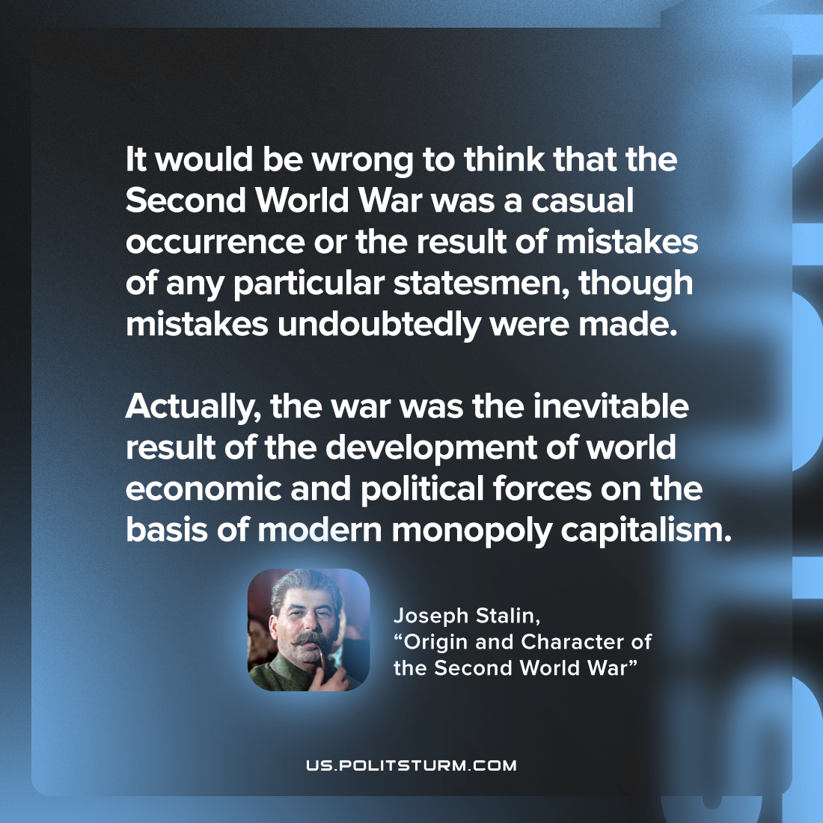

Original article
2023-05-06

"It would be wrong to think that the Second World War was a casual occurrence or the result of mistakes of any particular statesmen, though mistakes undoubtedly were made. Actually, the war was the inevitable result of the development of world economic and political forces on the basis of modern monopoly capitalism."
Joseph Stalin, “Origin and Character of the Second World War”

Original article

