Stalin on Real Socialism
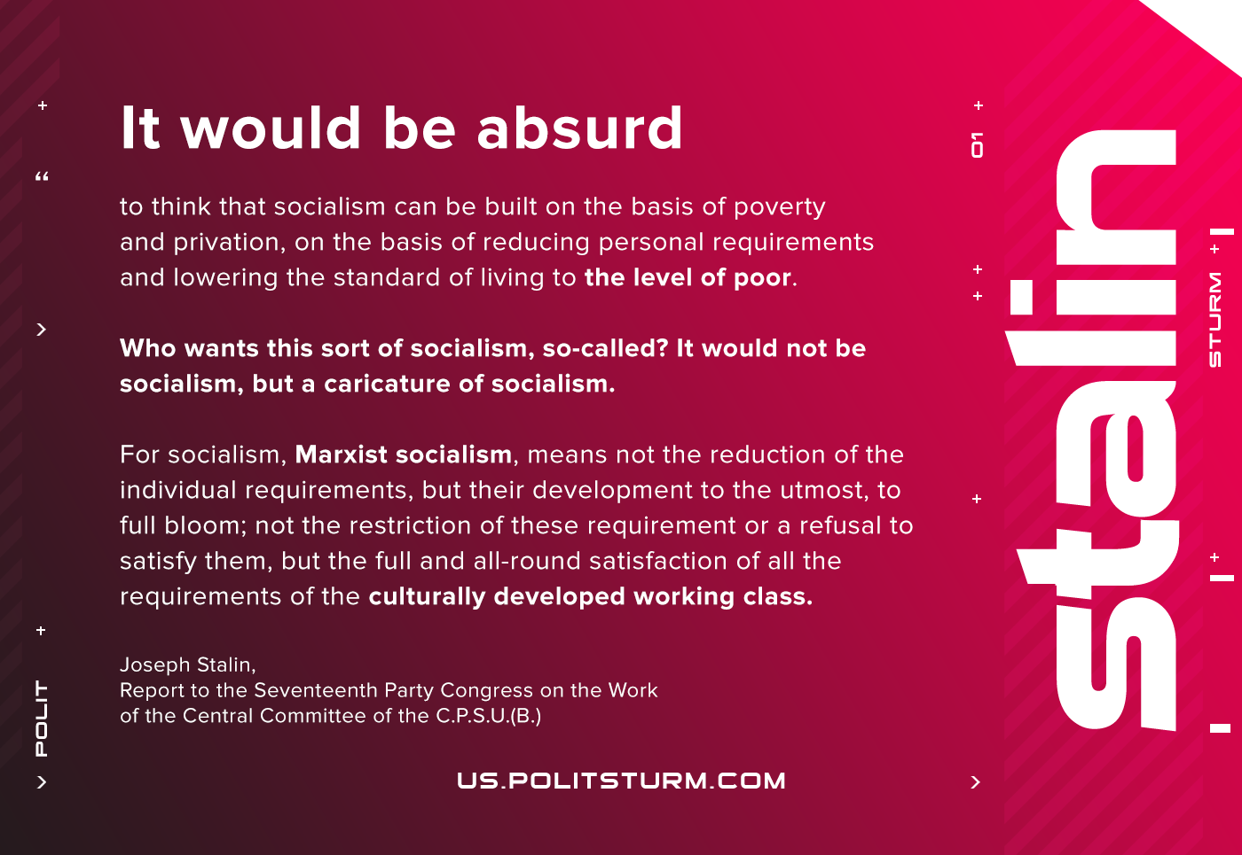

Original article
2021-06-27
1 min read

It would be absurd to think that socialism can be built on the basis of poverty and privation, on the basis of reducing personal requirements and lowering the standard of living to the level of the poor, who themselves, moreover, refuse to remain poor any longer and are pushing their way upward to a prosperous life. Who wants this sort of socialism, so-called? It would not be socialism, but a caricature of socialism.
For socialism, Marxist socialism, means not the reduction of individual requirements, but their development to the utmost, to full bloom; not the restriction of these requirements or a refusal to satisfy them, but the full and all-round satisfaction of all the requirements of culturally developed working people.
Joseph Stalin, “Report to the Seventeenth Party Congress on the Work of the Central Committee of the C.P.S.U.(B.)”

Original article

