Stalin on Private Property
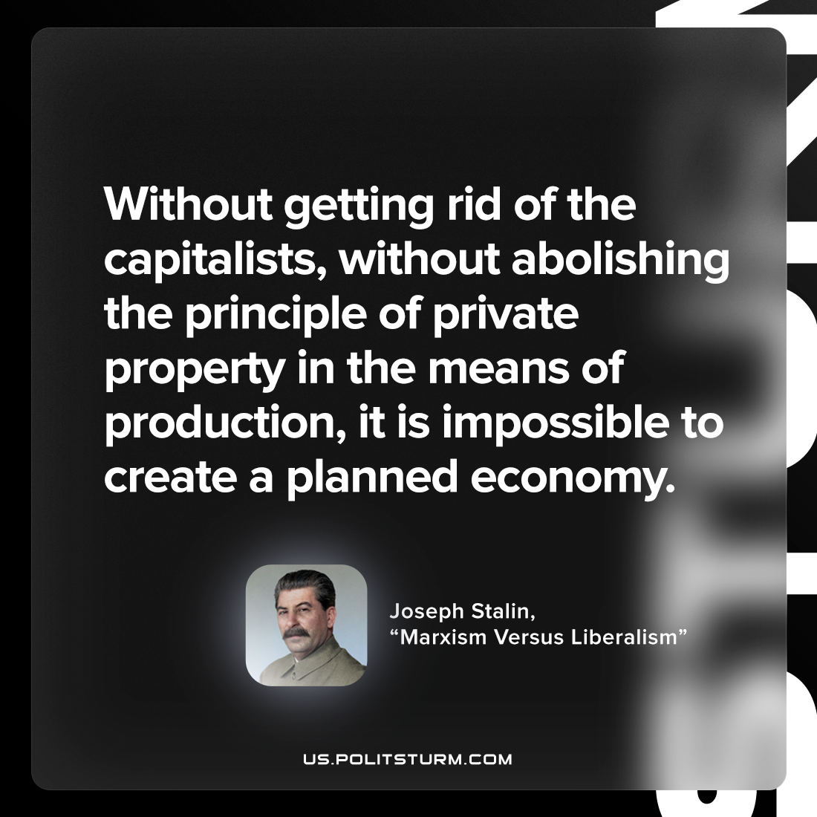

Original article
2023-05-02

"Without getting rid of the capitalists, without abolishing the principle of private property in the means of production, it is impossible to create a planned economy."
Joseph Stalin, "Marxism Versus Liberalism"

Original article

