Stalin on Private Property and Capital
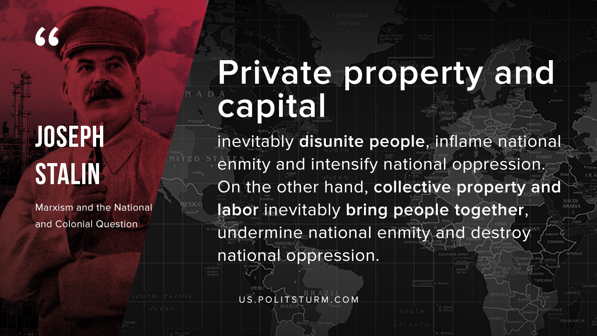

Original article
2019-11-12

Private property and capital inevitably disunite people, inflame national enmity and intensify national oppression. On the other hand, collective property and labor inevitably bring people together, undermine national enmity and destroy national oppression.
J.W. Stalin “Marxism and the National and Colonial Question”

Original article

