Stalin on Planned Economy
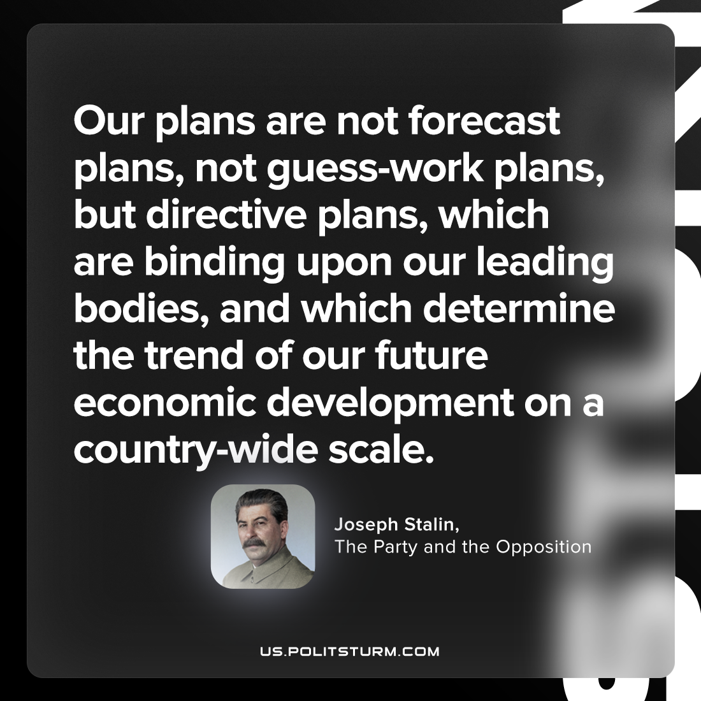

Original article
2023-05-25

"Our plans are not forecast plans, not guess-work plans, but directive plans, which are binding upon our leading bodies, and which determine the trend of our future economic development on a country-wide scale."
Joseph Stalin, “The Party and the Opposition”

Original article

