Stalin on Party Growth and Consolidation
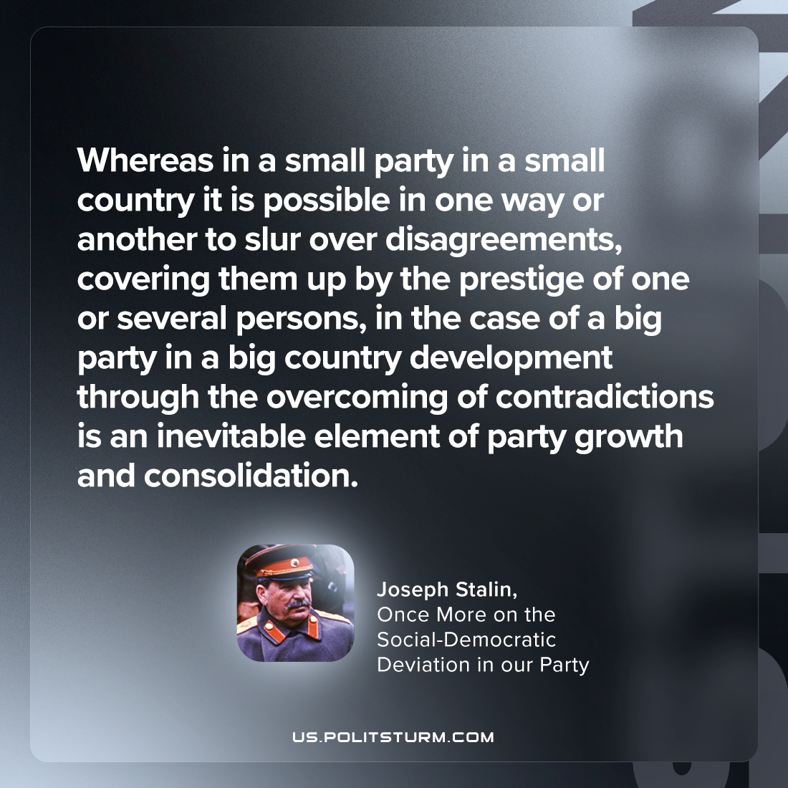

Original article
2023-04-27

"Whereas in a small party in a small country it is possible in one way or another to slur over disagreements, covering them up by the prestige of one or several persons, in the case of a big party in a big country development through the overcoming of contradictions is an inevitable element of party growth and consolidation."
Joseph Stalin, “Once More on the Social-Democratic Deviation in our Party”

Original article

