Stalin on October Revolution and Internationalism
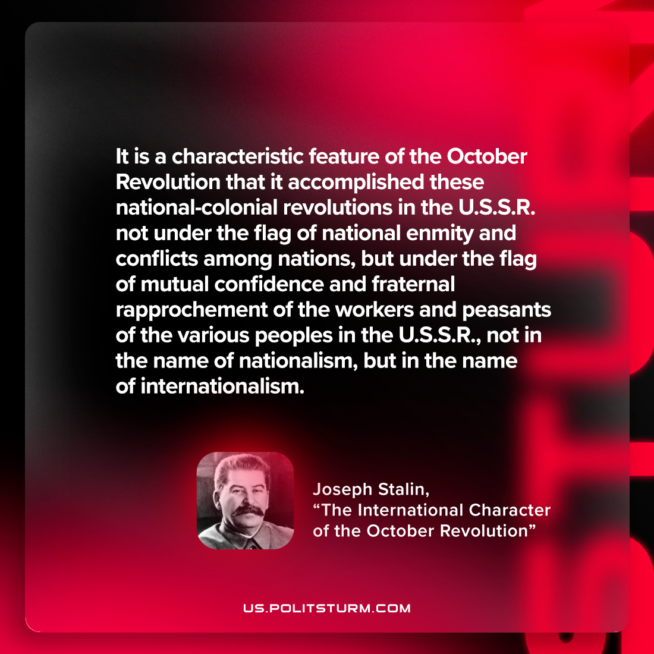

Original article
2023-01-29

"It is a characteristic feature of the October Revolution that it accomplished these national-colonial revolutions in the U.S.S.R. not under the flag of national enmity and conflicts among nations, but under the flag of mutual confidence and fraternal rapprochement of the workers and peasants of the various peoples in the U.S.S.R., not in the name of nationalism, but in the name of internationalism."
Joseph Stalin, "The International Character of the October Revolution"

Original article

