Stalin on Objectives of Capitalists
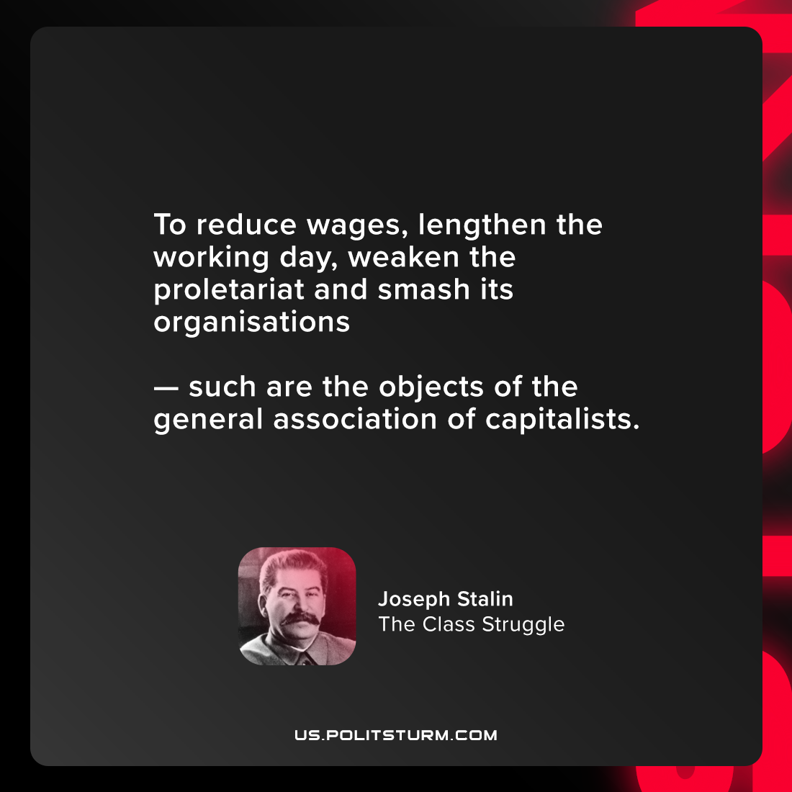

Original article
2021-08-27

To reduce wages, lengthen the working day, weaken the proletariat and smash its organisations — such are the objects of the general association of capitalists.

Joseph Stalin, “The Class Struggle”

Original article

