Stalin on Needs and Economic Relations
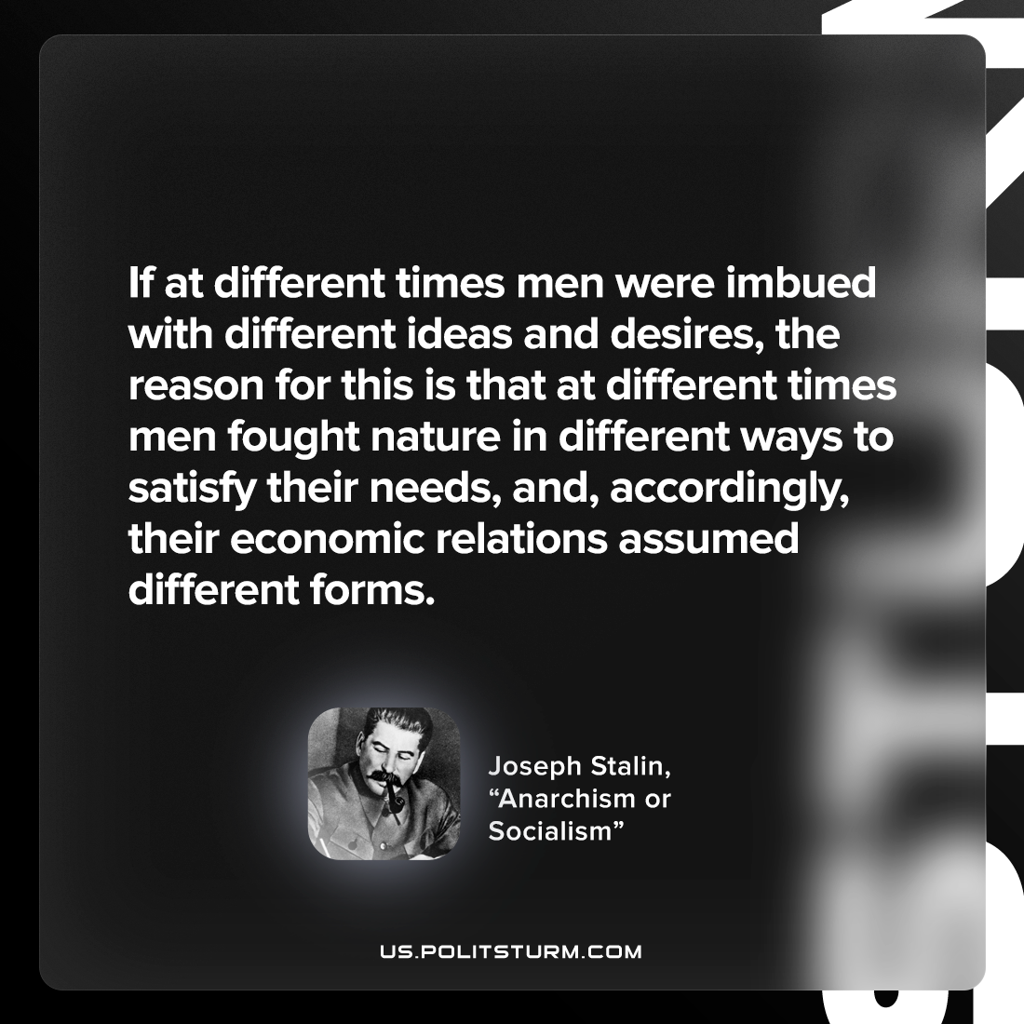

Original article
2022-11-26

If at different times men were imbued with different ideas and desires, the reason for this is that at different times men fought nature in different ways to satisfy their needs, and, accordingly, their economic relations assumed different forms.
Joseph Stalin, “Anarchism or Socialism”

Original article

