Stalin on Nationalist Expansion and Imperialism
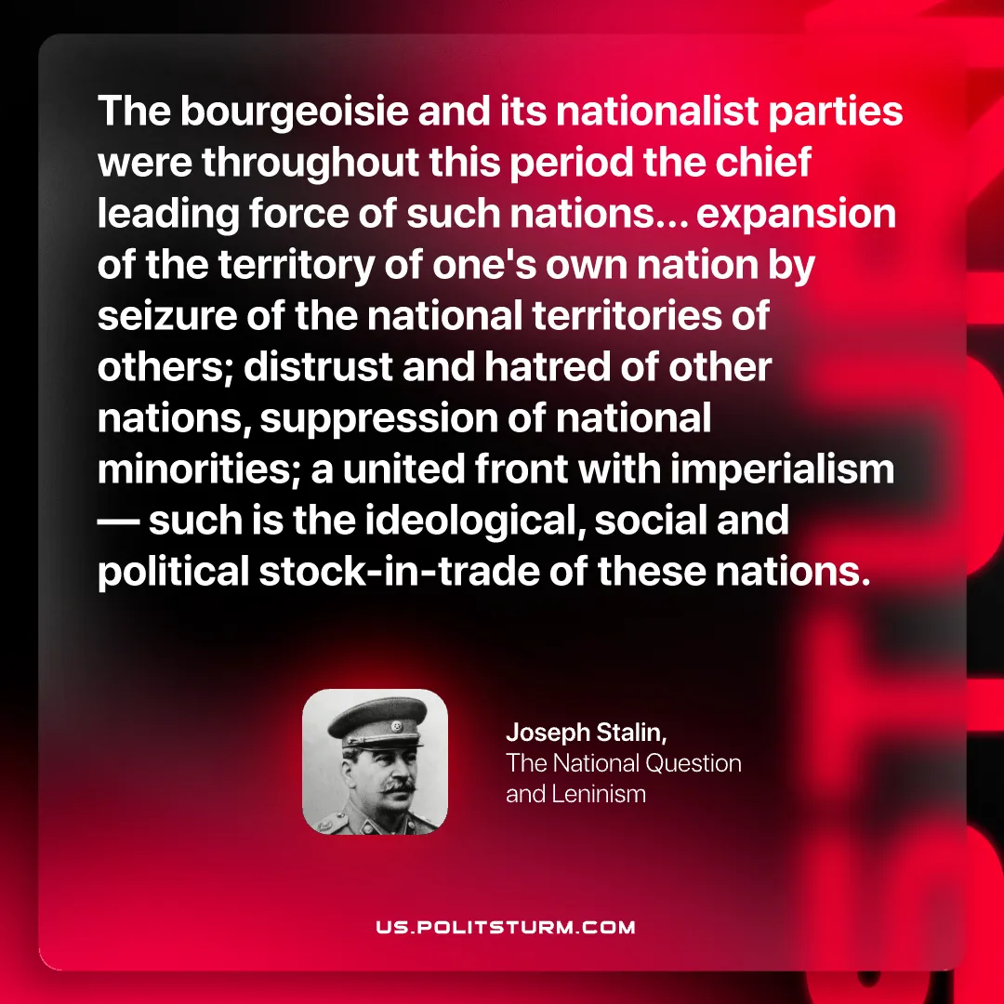

Original article
2026-08-20

The bourgeoisie and its nationalist parties were throughout this period the chief leading force of such nations... expansion of the territory of one's own nation by seizure of the national territories of others; distrust and hatred of other nations, suppression of national minorities; a united front with imperialism — such is the ideological, social and political stock-in-trade of these nations.
Joseph Stalin, The National Question and Leninism

Original article

