Stalin on National Struggle
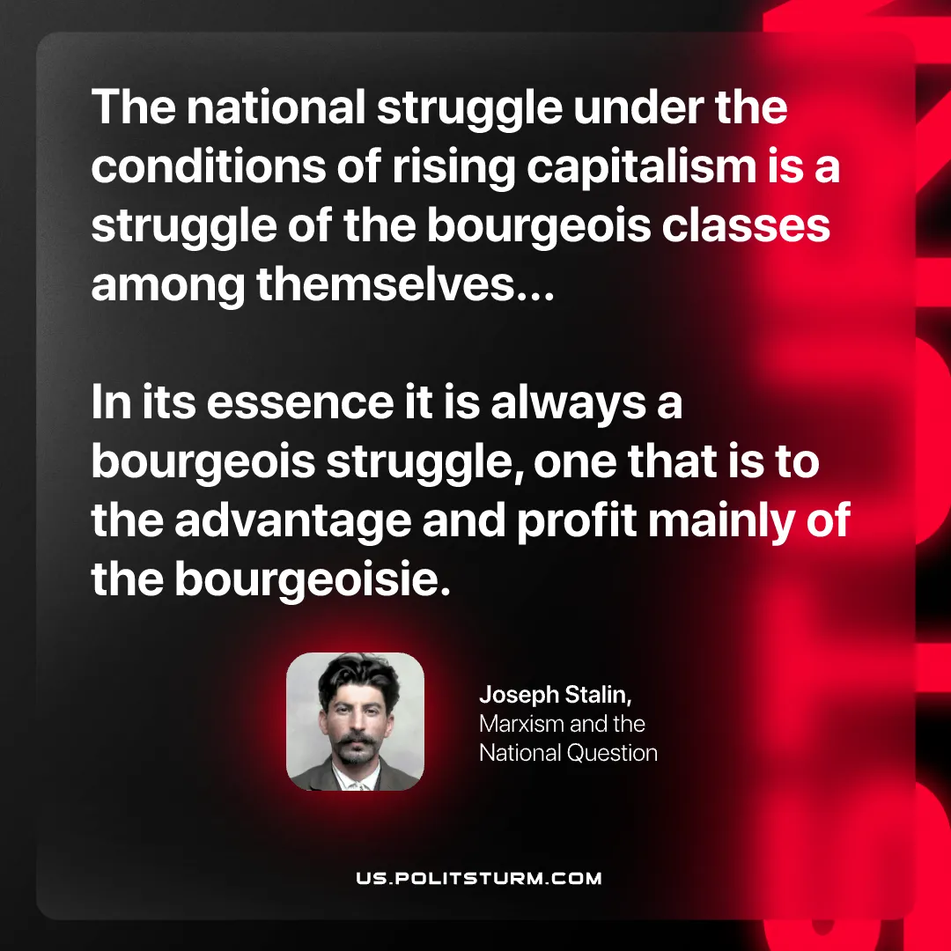

Original article
2026-08-18

The national struggle under the conditions of rising capitalism is a struggle of the bourgeois classes among themselves... In its essence it is always a bourgeois struggle, one that is to the advantage and profit mainly of the bourgeoisie.
Joseph Stalin, Marxism and the National Question

Original article

