Stalin on National Question
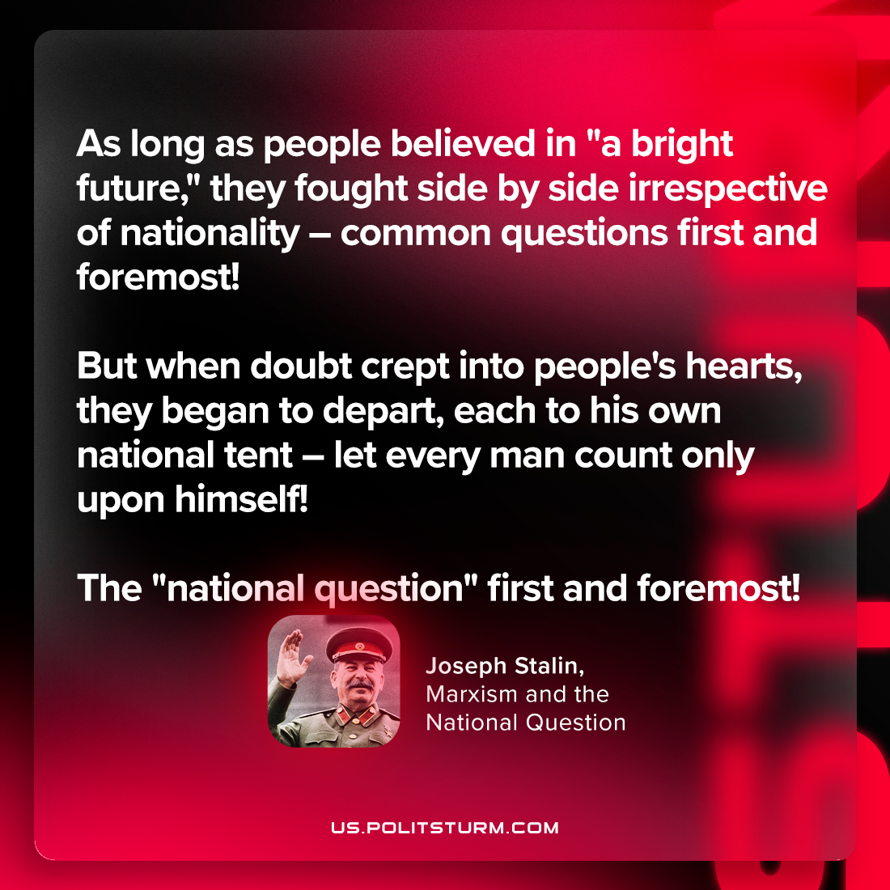

Original article
2023-10-03

"As long as people believed in "a bright future," they fought side by side irrespective of nationality – common questions first and foremost! But when doubt crept into people's hearts, they began to depart, each to his own national tent – let every man count only upon himself! The "national question" first and foremost!"
Joseph Stalin, "Marxism and the National Question"

Original article

