Stalin on Materialism, Theories and Policy
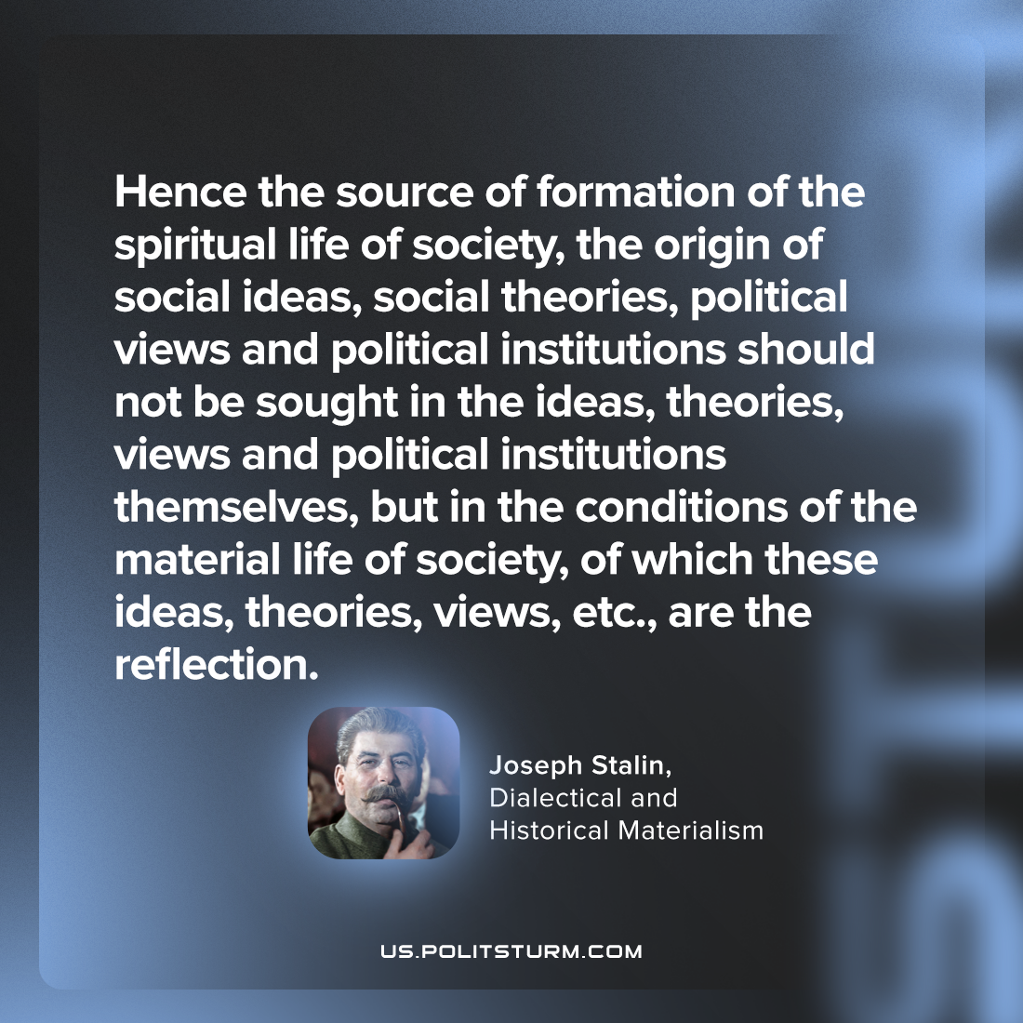

Original article
2023-05-30

"Hence the source of formation of the spiritual life of society, the origin of social ideas, social theories, political views and political institutions should not be sought in the ideas, theories, views and political institutions themselves, but in the conditions of the material life of society, of which these ideas, theories, views, etc., are the reflection."
Joseph Stalin, "Dialectical and Historical Materialism"

Original article

