Stalin on Marxism-Leninism
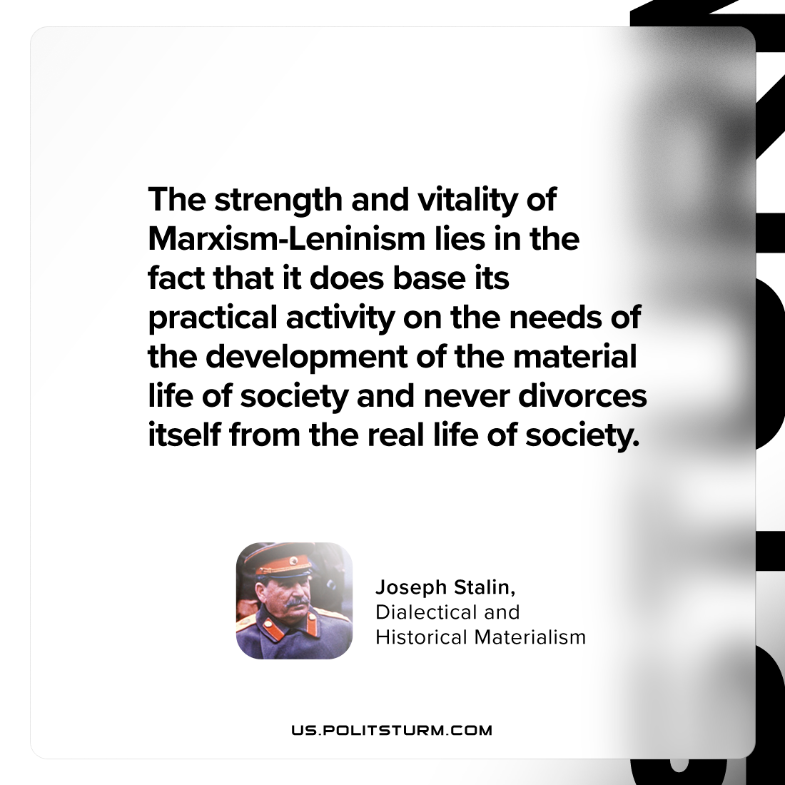

Original article
2024-01-25

"The strength and vitality of Marxism-Leninism lies in the fact that it does base its practical activity on the needs of the development of the material life of society and never divorces itself from the real life of society."
Joseph Stalin, Dialectical and Historical Materialism

Original article

