Stalin on Marxism and Social-Democrats
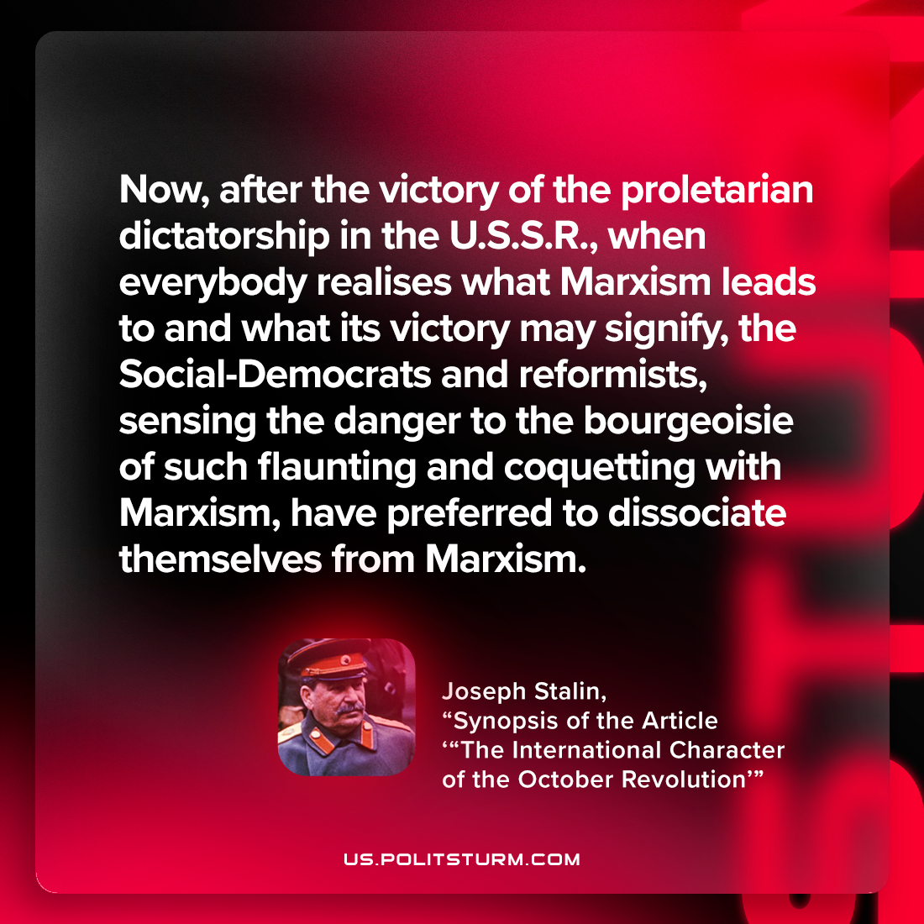

Original article
2023-03-23

"Now, after the victory of the proletarian dictatorship in the U.S.S.R., when everybody realises what Marxism leads to and what its victory may signify, the Social-Democrats and reformists, sensing the danger to the bourgeoisie of such flaunting and coquetting with Marxism, have preferred to dissociate themselves from Marxism."
Joseph Stalin, 'Synopsis of the Article “The International Character of the October Revolution”'

Original article

