Stalin on Liberty
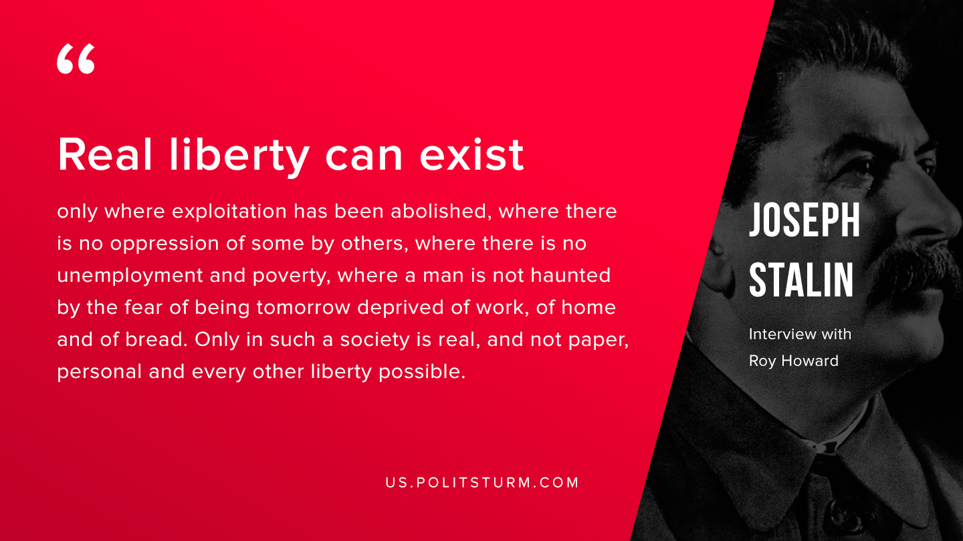

Original article
2019-08-13

Real liberty can exist only where exploitation has been abolished, where there is no oppression of some by others, where there is no unemployment and poverty, where a man is not haunted by the fear of being tomorrow deprived of work, of home and of bread. Only in such a society is real, and not paper, personal and every other liberty possible.
Joseph Stalin “Interview with Roy Hovard”

Original article

