Stalin on Liberalism
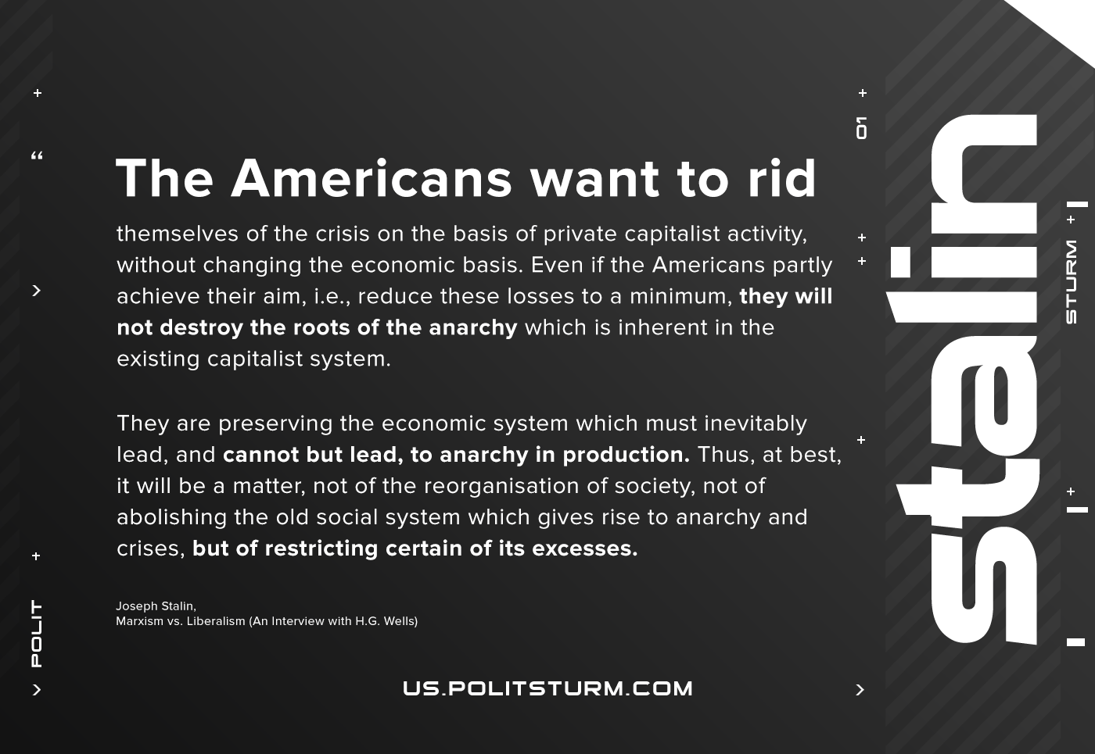

Original article
2021-06-27
1 min read

The Americans want to rid themselves of the crisis on the basis of private capitalist activity, without changing the economic basis. They are trying to reduce to a minimum the ruin, the losses caused by the existing economic system. Here, however, as you know, in place of the old, destroyed economic basis, an entirely different, a new economic basis has been created. Even if the Americans you mention partly achieve their aim, i.e., reduce these losses to a minimum, they will not destroy the roots of the anarchy which is inherent in the existing capitalist system.
They are preserving the economic system which must inevitably lead, and cannot but lead, to anarchy in production. Thus, at best, it will be a matter, not of the reorganisation of society, not of abolishing the old social system which gives rise to anarchy and crises, but of restricting certain of its excesses.
Joseph Stalin, Marxism vs. Liberalism (An Interview with H.G. Wells)

Original article

