Stalin on Leninism
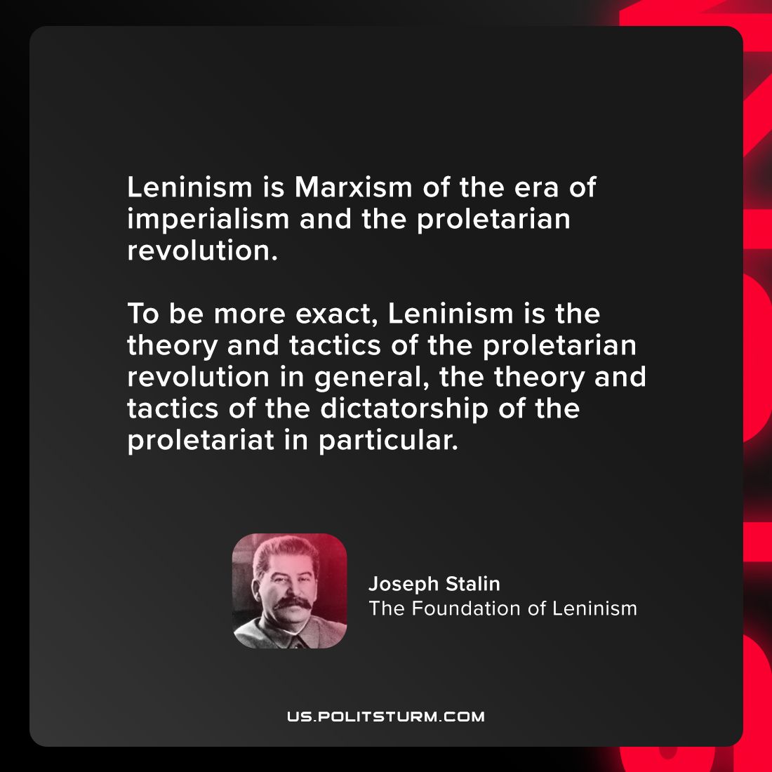

Original article
2021-09-08

Leninism is Marxism of the era of imperialism and the proletarian revolution. To be more exact, Leninism is the theory and tactics of the proletarian revolution in general, the theory and tactics of the dictatorship of the proletariat in particular.

Joseph Stalin, “The Foundation of Leninism”

Original article

