Stalin on Law Under Capitalism
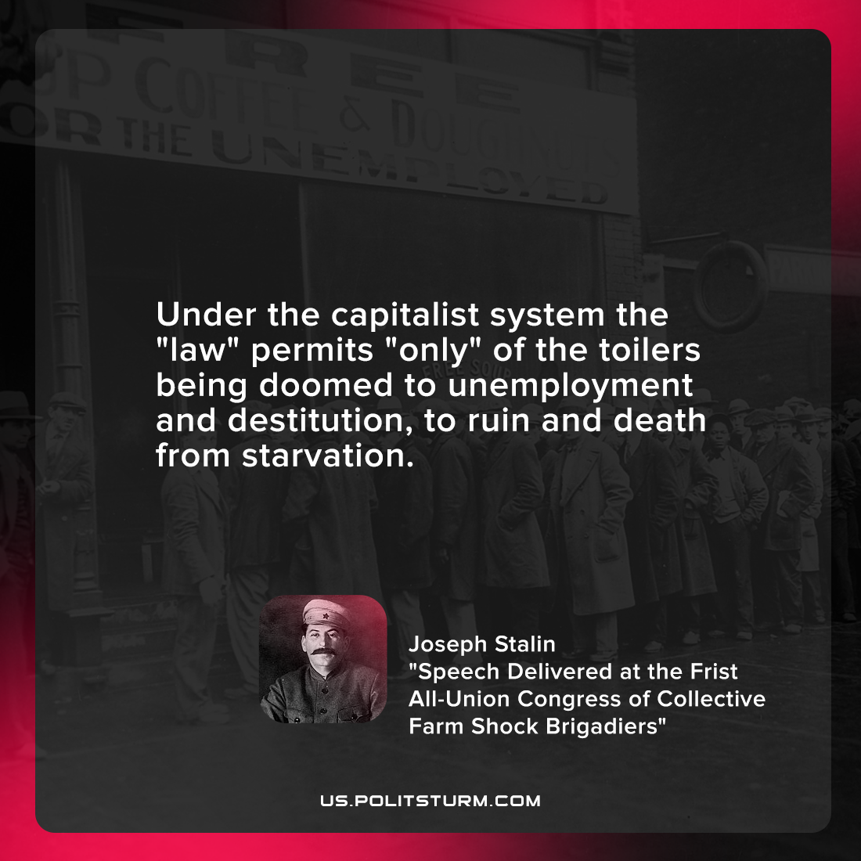

Original article
2022-03-18

Under the capitalist system the “law” permits “only” of the toilers being doomed to unemployment and destitution, to ruin and death from starvation.

Joseph Stalin, “Speech Delivered at the Frist All-Union Congress of Collective Farm Shock Brigadiers”

Original article

