Stalin on Imperialist Policy
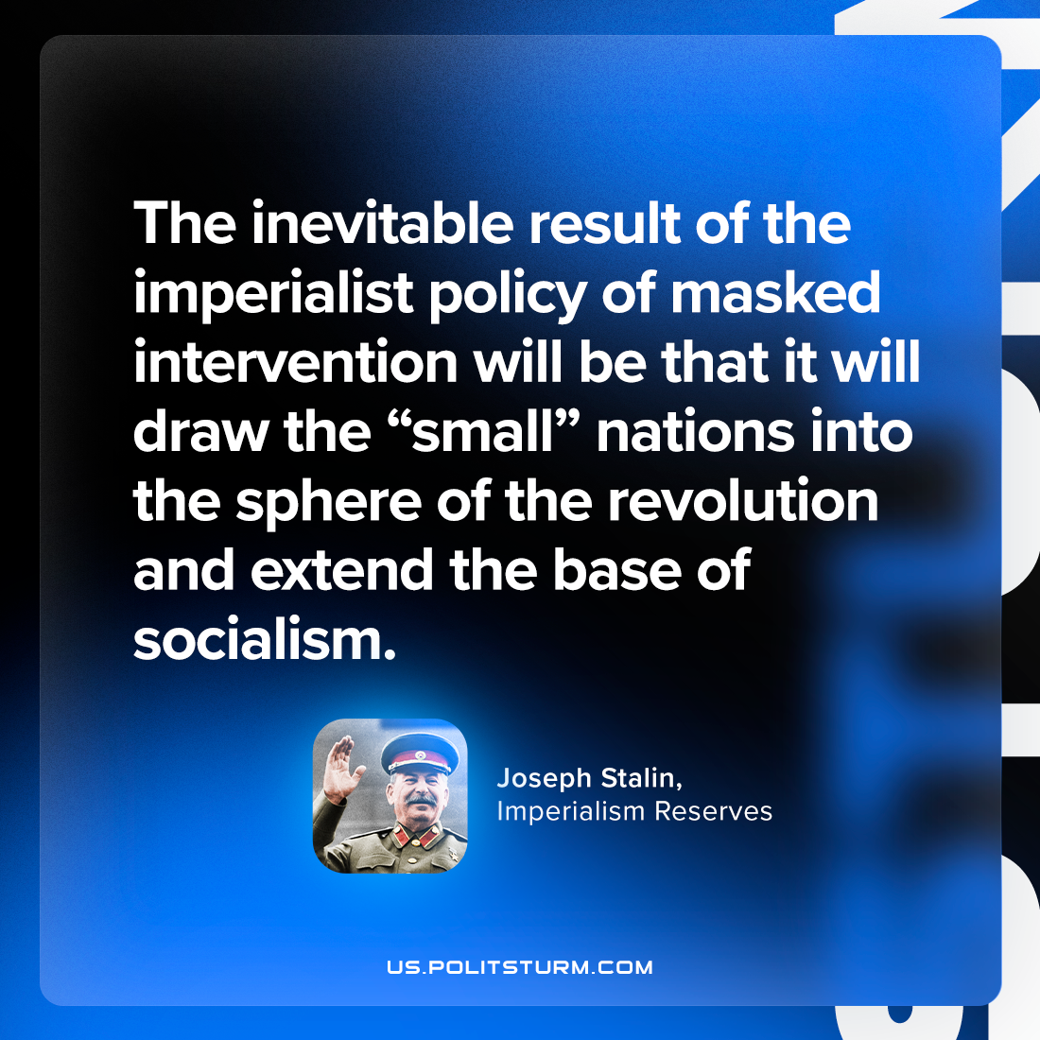

Original article
2023-04-25

"The inevitable result of the imperialist policy of masked intervention will be that it will draw the “small” nations into the sphere of the revolution and extend the base of socialism."
Joseph Stalin, “Imperialism Reserves”

Original article

