Stalin on Imperialism
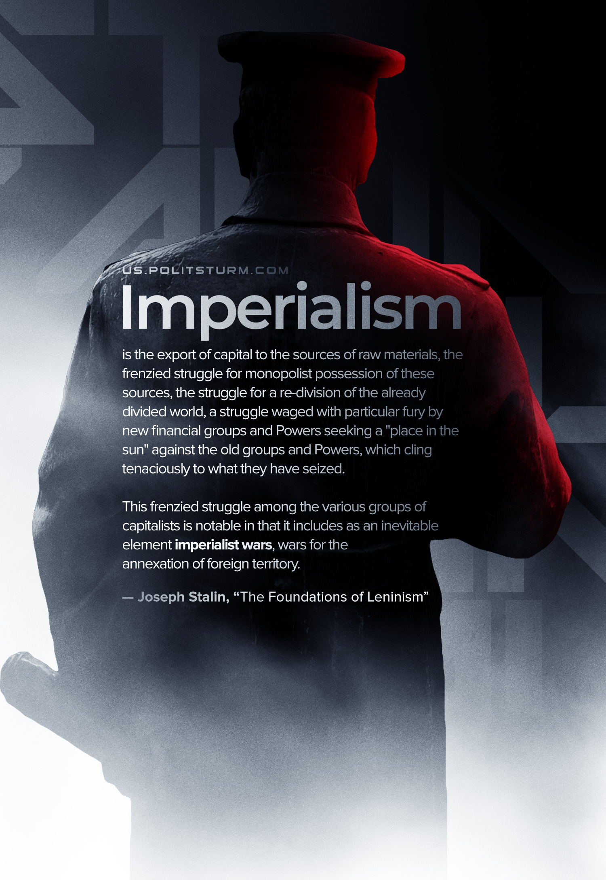

Original article
2022-07-07
1 min read

“Lenin called imperialism “moribund capitalism.” Why? Because imperialism carries the contradictions of capitalism to their last bounds, to the extreme limit, beyond which revolution begins. Of these contradictions, there are three which must be regarded as the most important…
The second contradiction is the contradiction among the various financial groups and imperialist Powers in their struggle for sources of raw materials, for foreign territory. Imperialism is the export of capital to the sources of raw materials, the frenzied struggle for monopolist possession of these sources, the struggle for a re-division of the already divided world, a struggle waged with particular fury by new financial groups and Powers seeking a “place in the sun” against the old groups and Powers, which cling tenaciously to what they have seized. This frenzied struggle among the various groups of capitalists is notable in that it includes as an inevitable element imperialist wars, wars for the annexation of foreign territory. This circumstance, in its turn, is notable in that it leads to the mutual weakening of the imperialists, to the weakening of the position of capitalism in general, to the acceleration of the advent of the proletarian revolution and to the practical necessity of this revolution.” – Joseph Stalin, “The Foundations of Leninism”

Original article

