Stalin on Imperialism or Revolution
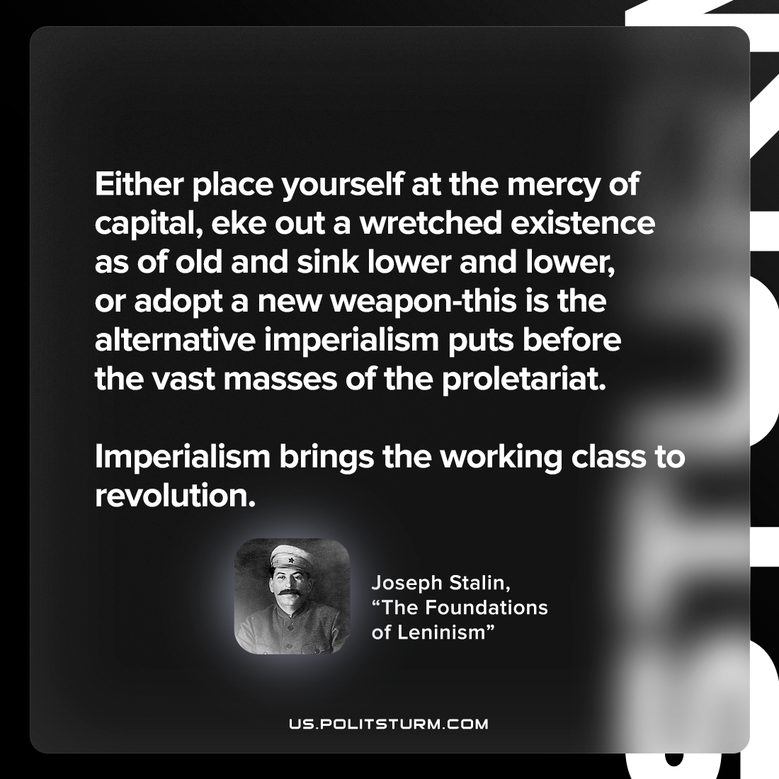

Original article
2022-10-12

Either place yourself at the mercy of capital, eke out a wretched existence as of old and sink lower and lower, or adopt a new weapon-this is the alternative imperialism puts before the vast masses of the proletariat. Imperialism brings the working class to revolution.

Joseph Stalin, “The Foundations of Leninism”

Original article

