Stalin on Ignoring the Division of Mankind into Classes
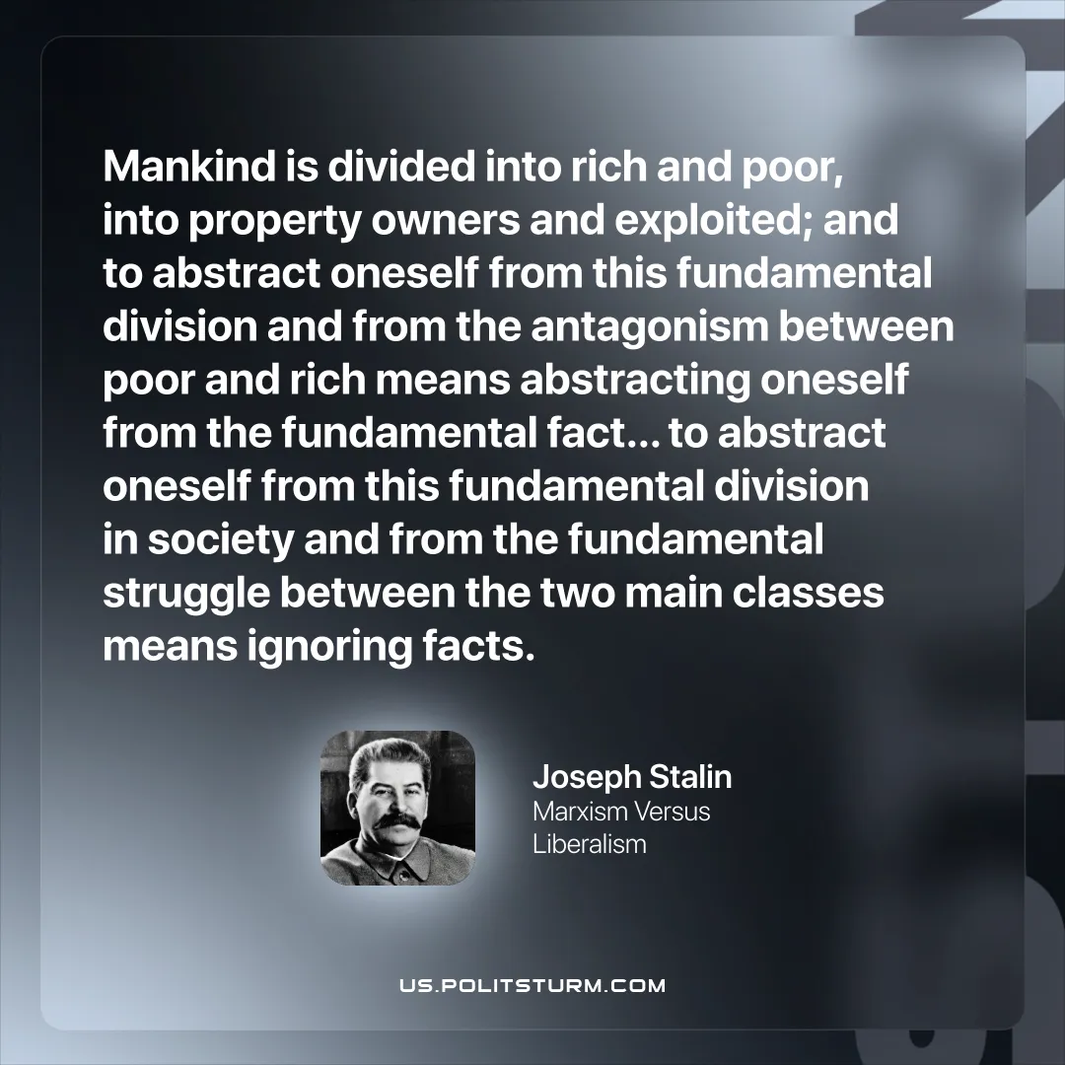

Original article
2026-04-07

“Mankind is divided into rich and poor, into property owners and exploited; and to abstract oneself from this fundamental division and from the antagonism between poor and rich means abstracting oneself from the fundamental fact… to abstract oneself from this fundamental division in society and from the fundamental struggle between the two main classes means ignoring facts.”
Joseph Stalin, Marxism Versus Liberalism

Original article

