Stalin on how Reformism Rots Socialism
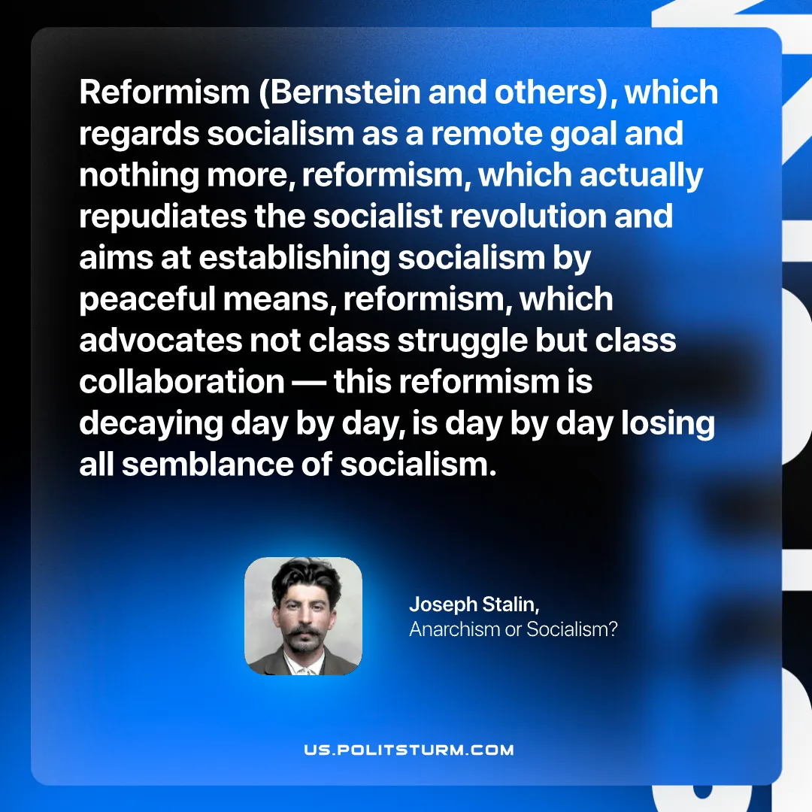

Original article
2026-08-11

Reformism (Bernstein and others), which regards socialism as a remote goal and nothing more, reformism, which actually repudiates the socialist revolution and aims at establishing socialism by peaceful means, reformism, which advocates not class struggle but class collaboration — this reformism is decaying day by day, is day by day losing all semblance of socialism.
Joseph Stalin, Anarchism or Socialism

Original article

