Stalin on how Imperialist War Starves Workers
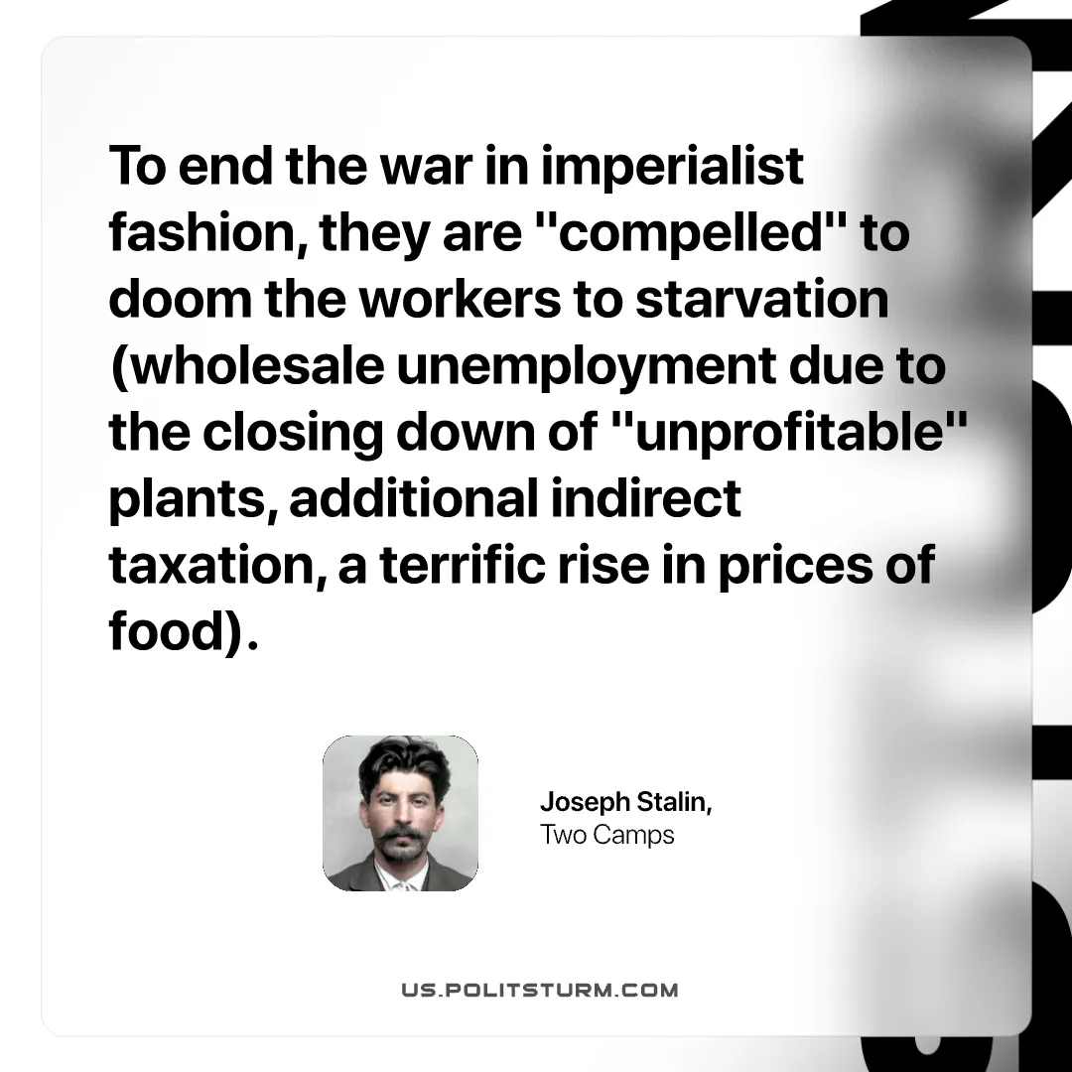

Original article
2026-08-22

To end the war in imperialist fashion, they are "compelled" to doom the workers to starvation (wholesale unemployment due to the closing down of "unprofitable" plants, additional indirect taxation, a terrific rise in prices of food)
Joseph Stalin, Two Camps

Original article

