Stalin on how Capitalists Deal with Crises
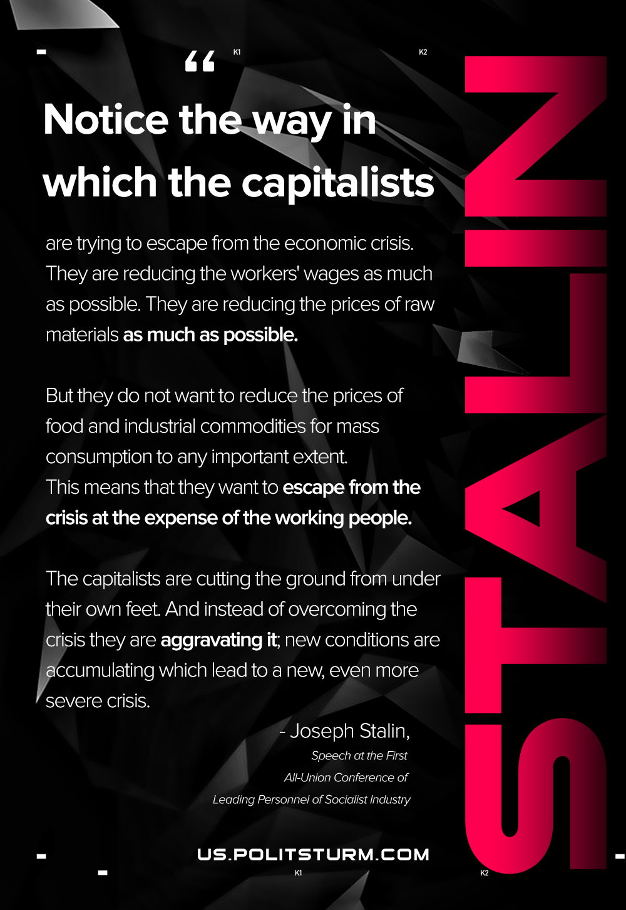

Original article
2021-01-03
1 min read

Notice the way in which the capitalists are trying to escape from the economic crisis. They are reducing the workers’ wages as much as possible. They are reducing the prices of raw materials as much as possible.
But they do not want to reduce the prices of food and industrial commodities for mass consumption to any important extent. This means that they want to escape from the crisis at the expense of the working people.
The capitalists are cutting the ground from under their own feet. And instead of overcoming the crisis they are aggravating it; new conditions are accumulating which lead to a new, even more severe crisis.
Joseph Stalin, Speech at the First All-Union Conference of Leading Personnel of Socialist Industry

Original article

