Stalin on Fascisation as Preparation for War
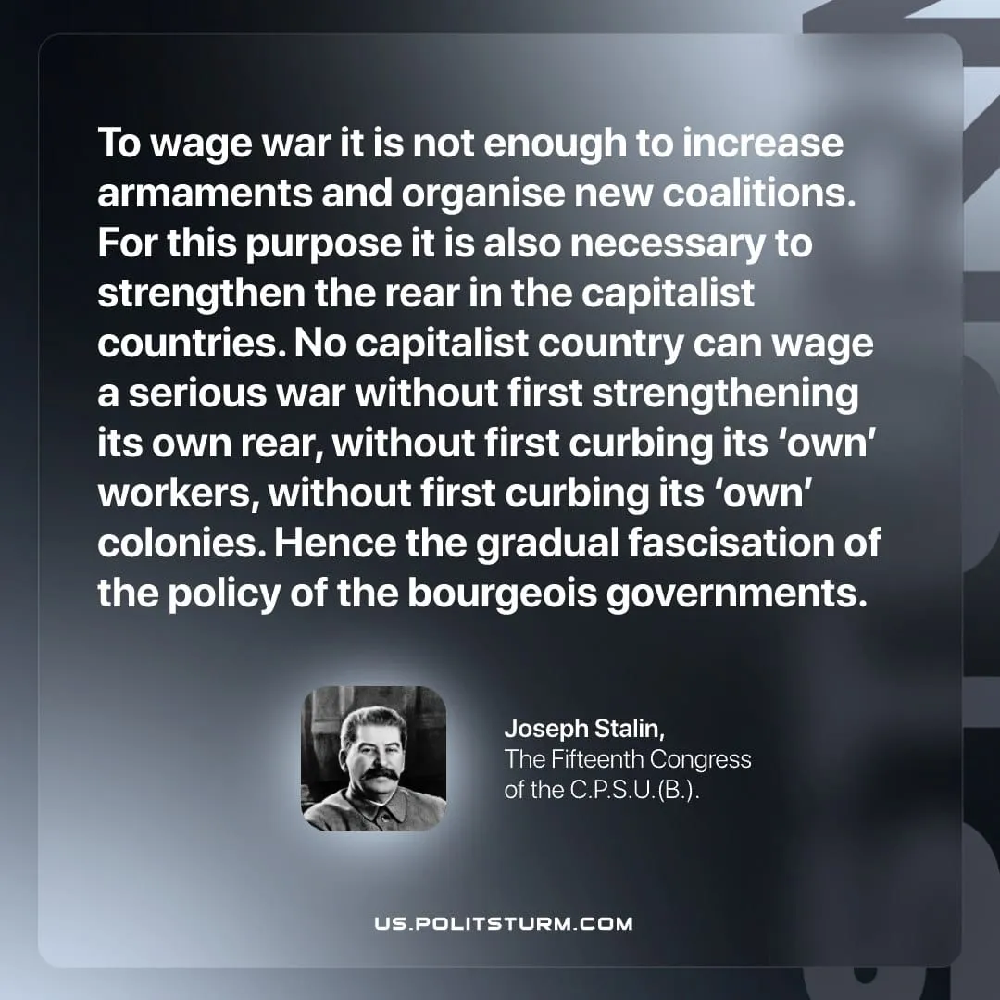

Original article
2026-05-09

To wage war it is not enough to increase armaments and organise new coalitions. For this purpose it is also necessary to strengthen the rear in the capitalist countries. No capitalist country can wage a serious war without first strengthening its own rear, without first curbing its ‘own’ workers, without first curbing its ‘own’ colonies. Hence the gradual fascisation of the policy of the bourgeois governments.
Joseph Stalin, The Fifteenth Congress of the C.P.S.U.(B.)

Original article

