Stalin on False Liberties
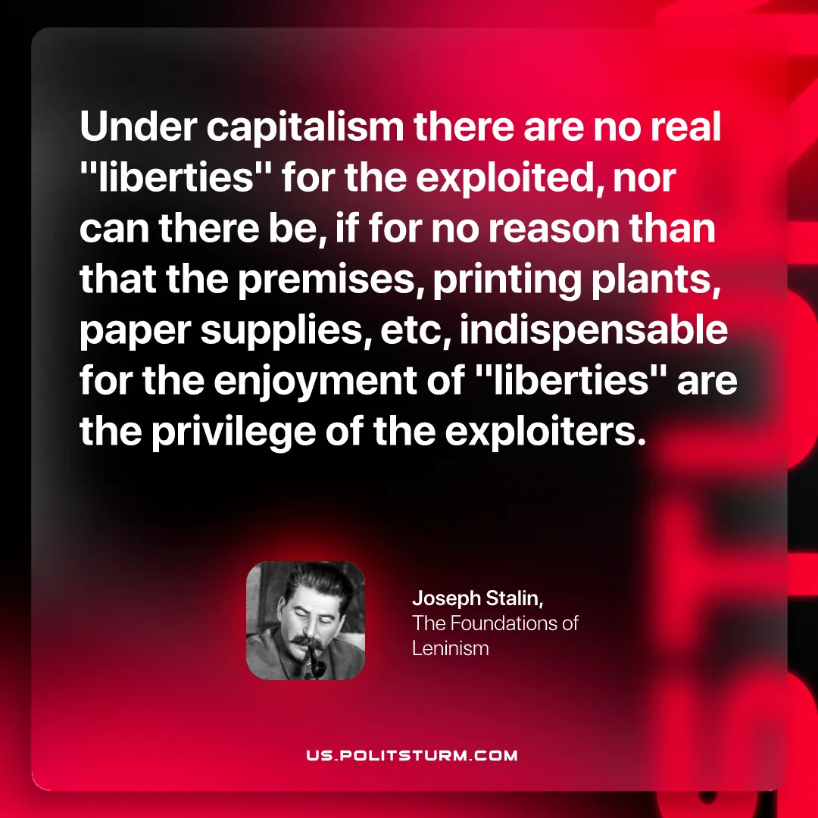

Original article
2026-09-19

Under capitalism there are no real "liberties" for the exploited, nor can there be, if for no reason than that the premises, printing plants, paper supplies, etc, indispensable for the enjoyment of "liberties" are the privilege of the exploiters.
Joseph Stalin, The Foundations of Leninism

Original article

