Stalin on Factions
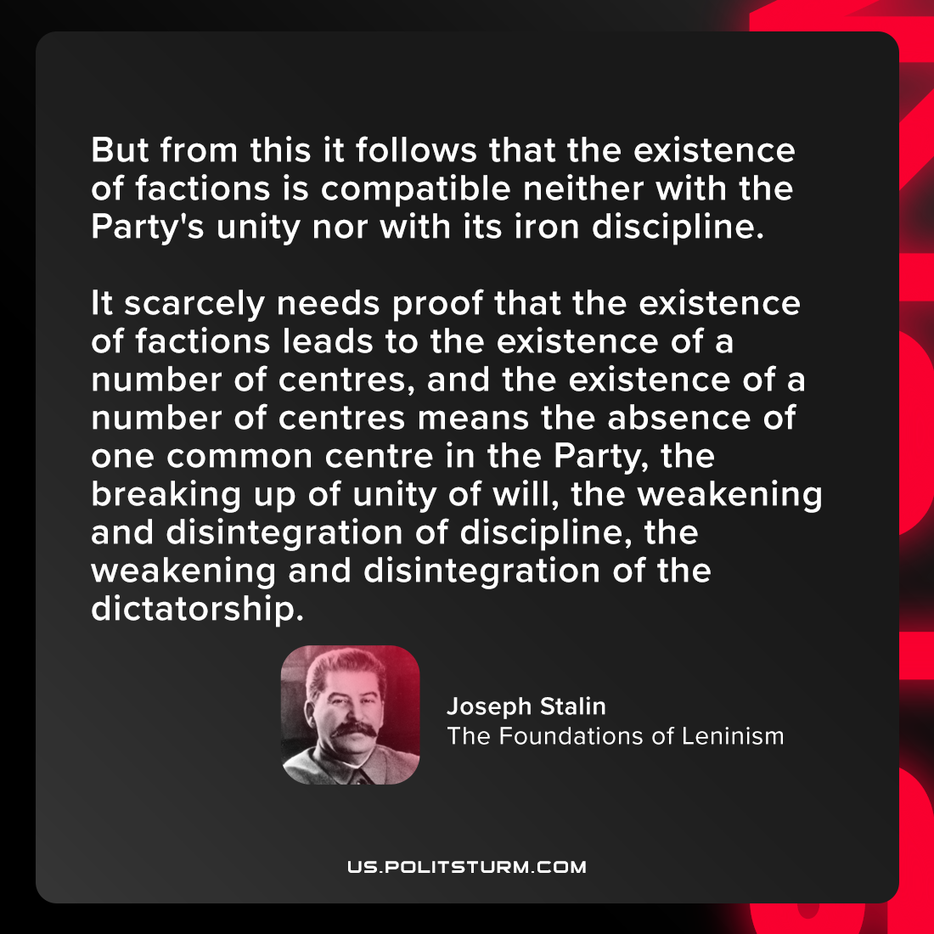

Original article
2021-08-03
1 min read

But from this it follows that the existence of factions is compatible neither with the Party’s unity nor with its iron discipline. It scarcely needs proof that the existence of factions leads to the existence of a number of centres, and the existence of a number of centres means the absence of one common centre in the Party, the breaking up of unity of will, the weakening and disintegration of discipline, the weakening and disintegration of the dictatorship.

Joseph Stalin, “The Foundations of Leninism”

Original article

