Stalin on Dialectics and Development
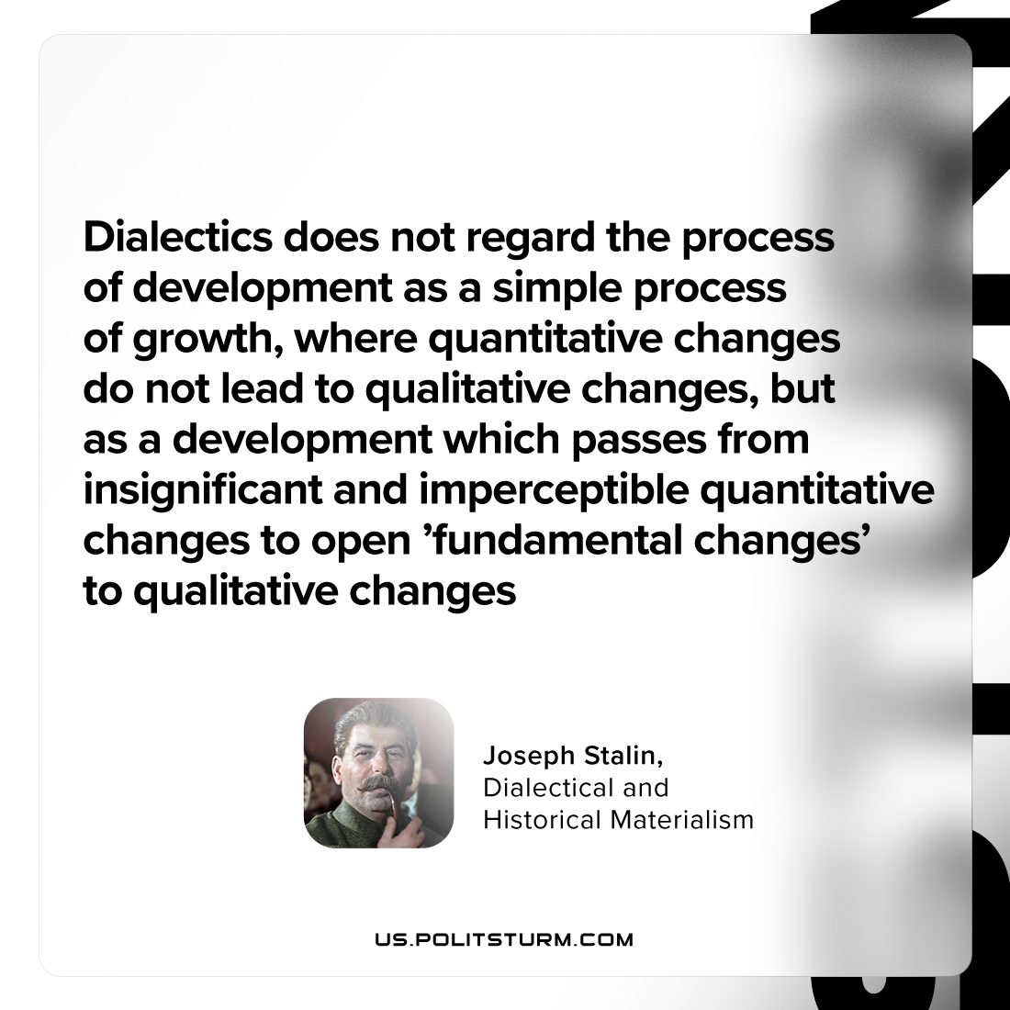

Original article
2023-08-20

"Dialectics does not regard the process of development as a simple process of growth, where quantitative changes do not lead to qualitative changes, but as a development which passes from insignificant and imperceptible quantitative changes to open ’fundamental changes’ to qualitative changes"
Joseph Stalin, Dialectical and Historical Materialism

Original article

