Stalin on Danger from the Right
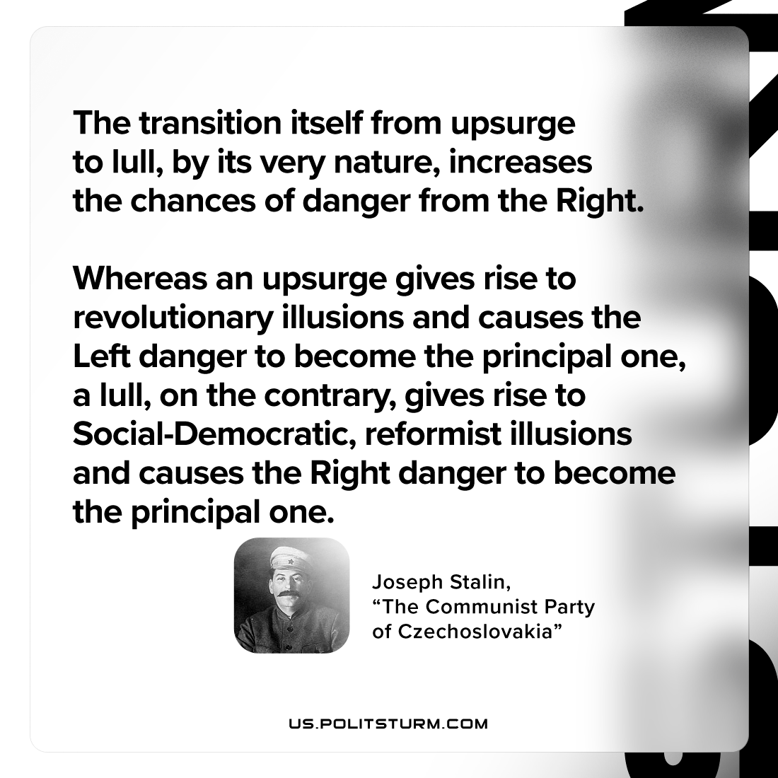

Original article
2023-03-14

"The transition itself from upsurge to lull, by its very nature, increases the chances of danger from the Right. Whereas an upsurge gives rise to revolutionary illusions and causes the Left danger to become the principal one, a lull, on the contrary, gives rise to Social-Democratic, reformist illusions and causes the Right danger to become the principal one."
Joseph Stalin, “The Communist Party of Czechoslovakia”

Original article

