Stalin on Communist Party and Connection with the Masses
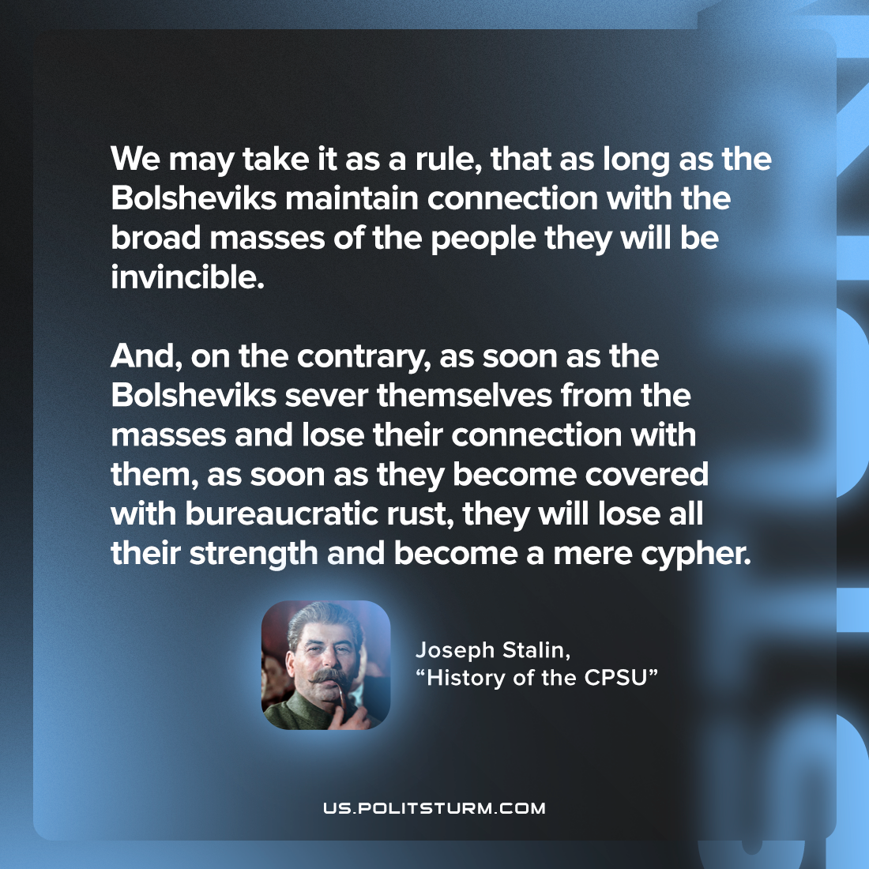

Original article
2023-05-16

"We may take it as a rule, that as long as the Bolsheviks maintain connection with the broad masses of the people they will be invincible. And, on the contrary, as soon as the Bolsheviks sever themselves from the masses and lose their connection with them, as soon as they become covered with bureaucratic rust, they will lose all their strength and become a mere cypher."
Joseph Stalin, "History of the CPSU"

Original article

