Stalin on Collectivism
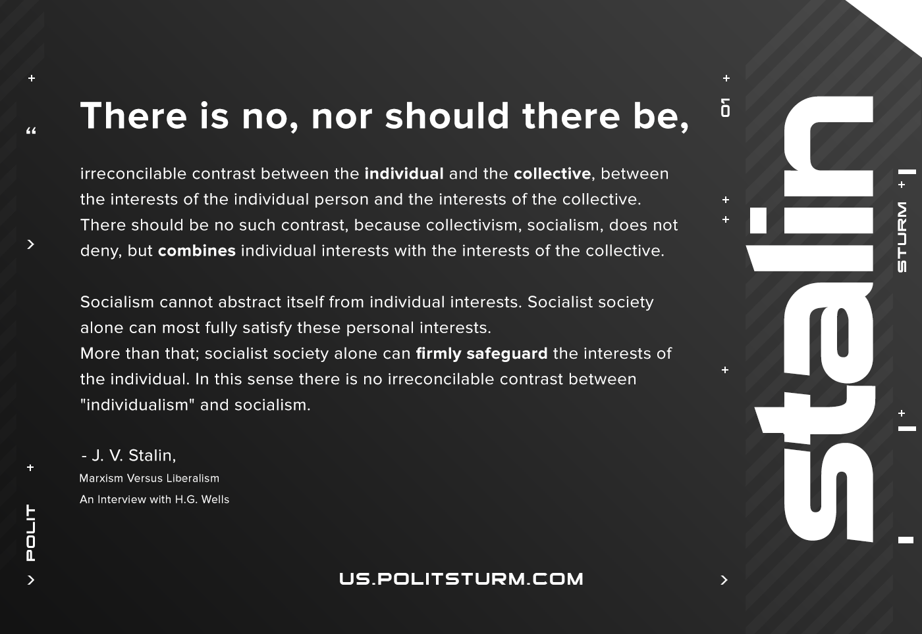

Original article
2020-11-13
1 min read

There is no, nor should there be, irreconcilable contrast between the individual and the collective, between the interests of the individual person and the interests of the collective. There should be no such contrast, because collectivism, socialism, does not deny, but combines individual interests with the interests of the collective.
Socialism cannot abstract itself from individual interests. Socialist society alone can most fully satisfy these personal interests. More than that; socialist society alone can firmly safeguard the interests of the individual. In this sense there is no irreconcilable contrast between “individualism” and socialism.
J. V. Stalin, Marxism Versus Liberalism, An Interview with H.G.Wells.

Original article

