Stalin on Class Ideologies
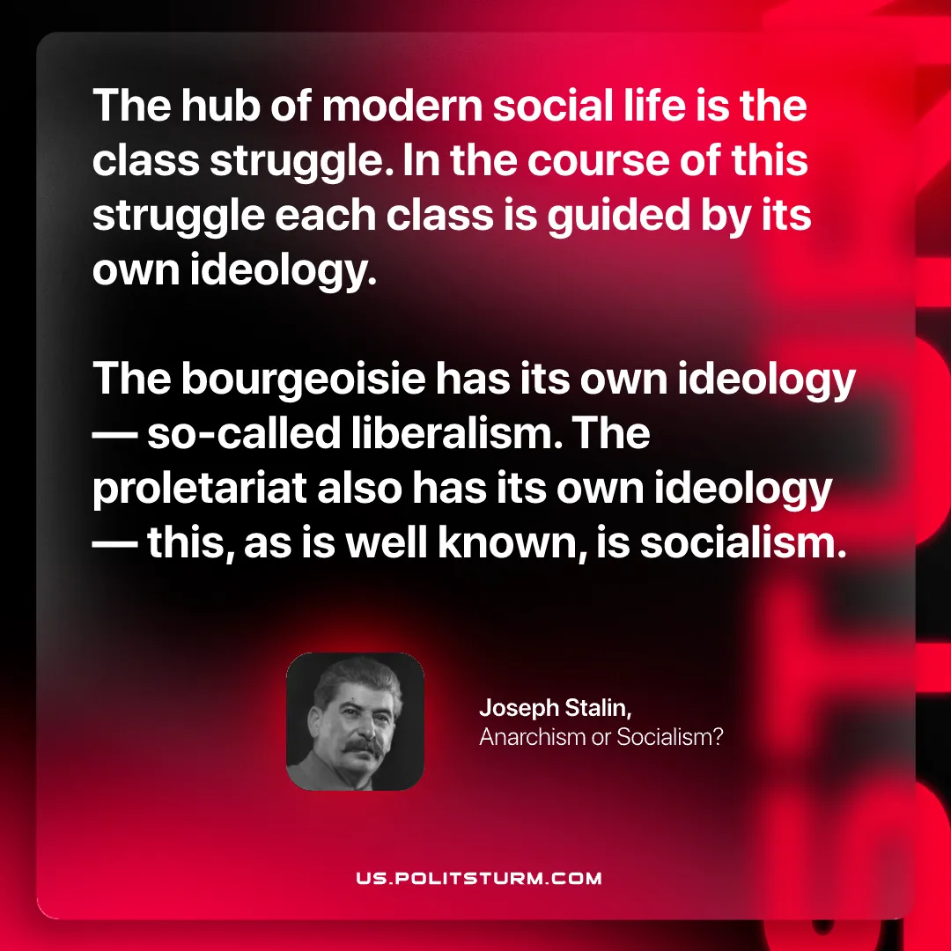

Original article
2026-08-15

The hub of modern social life is the class struggle. In the course of this struggle each class is guided by its own ideology. The bourgeoisie has its own ideology — so-called liberalism. The proletariat also has its own ideology — this, as is well known, is socialism.
Joseph Stalin, Anarchism or Socialism?

Original article

